
Statistics:

Normal Distributions and the Scientific Method

URL: http://mathbench.umd.edu/modules/prob-stat_normal-distribution/page01.htm

Note: All printer-friendly versions of the modules use an amazing new interactive technique called “cover up the answers”. You know what to do…

The Scientific Method
I am going to assume that you've read about the scientific method at least once (probably many times, if you've taken a lot of science classes). So, I'll spare you the long lecture – but if you've never read a good description of the scientific method or the diagram below is totally unfamiliar to you, please read up on it first, then come back here...
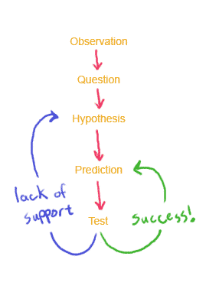
However, knowing what the scientific method is and being able to use it are 2 different things. I want to focus especially on HOW to design a sound scientific procedure for testing a hypothesis. Generally the test needs to have at least 3 characteristics:
- You need to specify how you will MEASURE the outcome of the treatment.
- You need to COMPARE the effects of some treatment to the effects of not-treatment (called the control).
- You need to REPLICATE your experiment so that random events don't hijack your results.

What makes a Good Procedure?
Here's the scenario: You have been hired by the new online mega-petstore G.O.P. (Guaranteed Overnight Pets) to formulate a new fish food. Their current fish food produces rather slow growth, requiring too many days to rear fish to an acceptable weight for being sent through the mail.
You've done the hard work -- tested various kinds of insect larvae, nematodes, and algae, you have created (you believe) the perfect formula, named it "Fish2Whale", and sent it off. You are waiting for your paycheck when instead you receive a rather terse note:
Sir/Madam:
Please be advised that we do not intend to make any payment for your formula, "Fish2Whale". We tried it out on Edgar, the company mascot, and he didn't seem to get very big.
Sincerely,
G.O.P.
You might be excused for feeling a bit put out at this point. Management at G.O.P. has not followed the scientific method when they tested your formula. Below I list several statements about fishfood. Pick out the one(s) which describe a satisfactory test of your fishfood. (This is not the same as picking the statements that you think are the most likely explanations. All we care about is that the idea is stated in a way that is testable.)

Good scientific procedure?
Procedure | Answer
If you feed a group of fish with Fish2Whale and they get to be at least 10 cm long, that proves that Fish2Whale works. | Not a good procedure: there is no group to compare the Fish2Whale fish with.
You should write back and tell the company that Fish2Whale is healthy for fish and will make their scales shine. | This is not a scientific procedure, this is a commercial! Fish2Whale is healthy compared to what? And how will you compare their effects?
You should feed one fish Fish2Whale and one fish normal food, and see which fish gets bigger. | It's good that you are comparing your treatment to a control, but what if the 'treatment' fish (the one you're feeding Fish2Whale to) happens to be sickly?
You should write back and tell them that its stupid to use the old food when they've already bought the new food. | "Stupid" is a value judgement, not a testable proposition. This is not even a commercial, it's just career suicide!
You should feed normal fish food to one group of fish (the control group) and Fish2Whale to another group of fish (the treatment group) and see which group does better. | This is pretty close. You have a comparison and replication, but you don't have a way to measure which group is "doing better" (length? weight? number of surviving offspring? scale shininess?)
You should feed normal fish food to one group of fish (the control group) and Fish2Whale to another group of fish (the treatment group) and see which group grows longer in length. | This is a sound scientific procedure. You have a way to measure success, something to compare your success to, and replication to ensure that random effects don't screw up your experiment.

Once again, make sure that when you design an experiment, you think in terms of MEASURE-COMPARE-REPLICATE. And when you are analyzing an experiment, look to see how the authors used each of these elements.

Normal Fish
Now, why do you need to replicate? Think what would happen if you treated one fish with Fish2Whale, and gave normal fishfood to one other fish. Just by chance, you might happen to pick a scrawny, weakly fish for the treatment, and a robust, strapping fish for the control. Of course you would try not to, but sometimes its hard to tell a fish by its scales. Or, your treatment fish might happen to get the fish version of stomache flu, or fall in love, or all sorts of other things could happen that would mess up your experiment.
The "insurance", so to speak, is to use LOTS of treatment fish, and also lots of control fish. This is called replication. But there's a slight catch. You put lots of fish in a tank and try to treat them all the same, and feed them all Fish2Whale, but they don't all grow to be exactly the same size. In a way, that's the point -- the reason why you have to replicate is that fish DON'T react in a completely predictable manner. But still, it creates a problem. How do you summarize the growth of a hundred or so fish?
If you are lucky, the sizes of fish will be similar to what's called a "normal distribution". The reason its called "normal" is that it is seen so often in nature that it seems like the “normal” distribution. This kind of distribution occurs when many factors influence an outcome -- for example, fish growth is affected by temperature, light, general health of the fish, ability to compete with other fish, and so on. Normally, for any given fish, some of these factors are positive and some of negative, so most fish end up close to the average. For a few fish, all the factors line up just right, and those fish get bigger than normal. For a few fish, everything or almost everything goes wrong, and those fish turn out quite small.
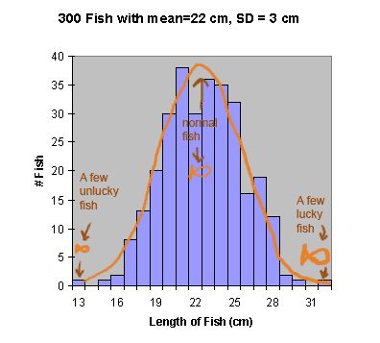

More about normal distributions
And here are some specific (and real) normal distributions:
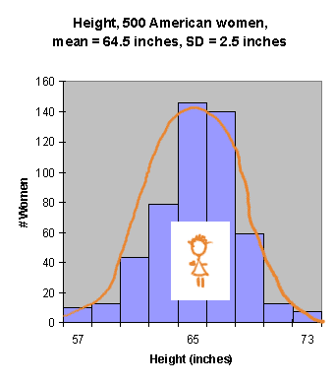 | 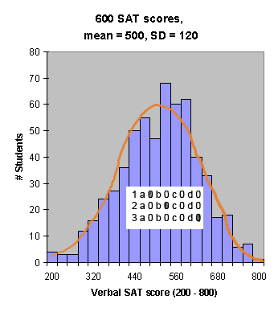
Adult height is affected by a variety of factors:  - nutrition  - maternal environment of the fetus  - numerous genes  - childhood illnesses... | SAT scores are affected by a variety of factors:  - education and quality of school  - first language  - student motivation  - amount of sleep the night before...
An amazing fact is that IDEAL normal distributions can be described by 2 parameters (“parameter” being a fancy word for “number”). These two parameters are:
- where the distribution is centered – or, the value at the peak. This is called the mean.
- how wide the distribution is – or, how much variability there is in the thing you're measuring.
How to measure the mean: just find the peak, drop a line down to the x-axis, and that's your mean. Here are the 2 distributions from above:
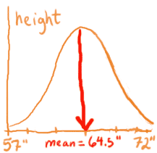 | 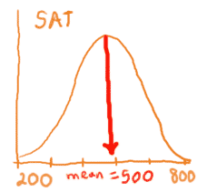
Its harder to measure how wide the distribution is. Very big or very small fish, people, and SAT scores do occur, at least with a small probability. So instead of measuring the entire width, we measure the middle two-thirds (actually the middle 68%, for mathematical reasons). This is called the Standard Deviation, or SD. Again, the distributions from above:
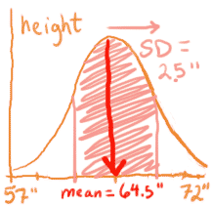 | 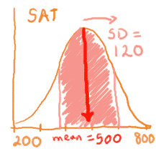
So,“68% of the observations” fall between plus and minus 1 SD. Another way of saying this is that if you measure plus and minus 1 SD from the mean, you will shade 68% of the area under the curve. Most of us are not very good at eye-balling 68% of a curvy shape, and there is a mathematical formula for determining the standard deviation. For now, just remember that the standard deviation (SD) measures how far you have to go FROM THE MEAN along the x-axis to encompass 68% of the population – in other words, the SD measures how variable the population is.

Visualizing a normal distribution
The online version of this module contains an interactive applet which allows you to practice with mean and standard deviation of a population of Fish and answer the following questions. To find this applet go to: http://mathbench.umd.edu/modules/prob-stat_normal-distribution/page05.htm | 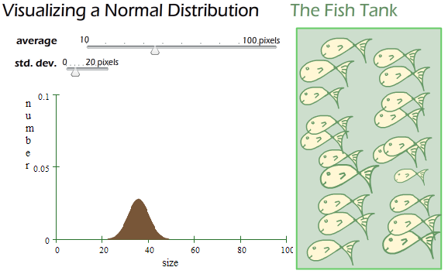

Questions | Answers
How does the curve change when you increase the mean, but keep the SD constant? | The curve shifts to the right (larger fish sizes) but the shape does not change
How does the curve change when you increase the SD, but keep the mean constant? | The curve stays in the same position but it flattens out (a wider range of sizes become common)
What happens when you DECREASE the SD? | The curve gets pointier (a narrower range of sizes) and eventually at SD=0, it becomes a single bar
What does the population look like when the mean and SD are approximately the same? | There is a lot of variability in size -- from close to zero up to more than double the mean (remember 68% of the population is within 1 SD of mean --> in this case from 0 to double the mean)
What does the population look like when the mean is much larger than the SD? | The fish vary only a little in size

Testing Fish2Whale
Recall that, after an angry exchange of emails, the winning procedure for testing Fish2Whale fishfood was:
- Feed normal fish food to one group of fish (the control group) and
- Feed Fish2Whale to another group of fish (the treatment group) and
- See which group grows longer in length.

Here is the data your lab got:
Control group mean length 22 cm, SD 3 cm
Treatment group mean length 25 cm, SD 3 cm

What percentage of the control group fish are between 22 and 25 cm?
- Remember that 68% of a normal population falls between plus and minus 1 SD.
- The control group mean plus 1 SD = 22+3 = 25
- This is the same as asking what percentage of the population is between the mean and the mean + 1 SD.
- A normal distribution is symmetrical.
Answer: 34% (half of 68%, since 22 to 25 is the same as the mean and the mean + 1 SD

What percentage of the treatment group fish are between 22 and 25 cm?
- This is the same as asking what percentage of the population is between the mean and the mean + 1 SD.
Answer: 34%

Exploring the Fish2Whale Distribution
Here is a picture of the distribution of fish sizes for the treatment (Fish2Whale) group. Notice that, if the fish follow an IDEAL normal distribution, we can make a lot of statements about their size distribution (i.e., what percentage of fish are in what size group):

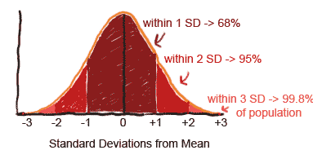
Questions | Answers
What percentage of fish fall between 25 and 28cm? | 34 %
What percentage of fish fall between 22 and 28 cm/ | 68 %
What percentage of fish are longer than 28 cm/ | 16 %
What percentage of fish are longer than 31 cm? | 15.5 %

We can do the same thing with ANY ideal normal distribution, such as the height of adult women, or the SAT scores of incoming freshmen...
- 68% of the normal distribution falls within 1 SD of the mean
- 95% falls within 2 SDs of the mean
- 99% falls within 3 SDs of the mean
This is sometimes abbreviated as "the 68-95-99.8% rule"

Overlapping Distributions
The online version of this module contains an interactive applet which allows you to find out the effects of changing mean and standard deviation on the graph of Fish2Whale distribution and answer the questions below. To find this applet go to: http://mathbench.umd.edu/modules/prob-stat_normal-distribution/page08.htm | 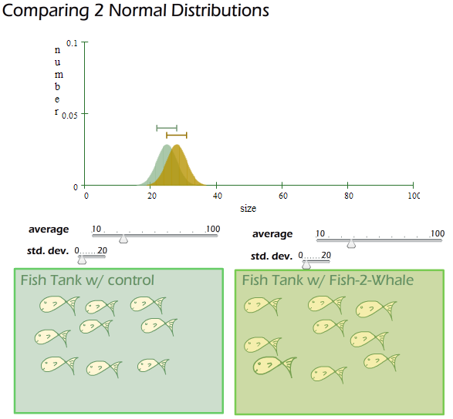
Your boss decides that Fish2Whale needs to be improved -- but he doesn't want to spend any more money than he has to. He wants to make Fish2Whale just better enough that the two distributions overlap by only 5%. Your job is to find how to do this.
Questions | Answers
Do you think it is possible to change MEAN fish growth enough to achieve only 5% overlap? (Just eyeball the overlap, don't worry about quantifying it). | Yes, if the mean size for Fish2Whale was about 40, rather than 28.
Do you think it is possible to change the STANDARD DEVIATION of fish growth enough to achieve only 5% overlap? | To do this, you have to have both SDs close to 0.

Do you think it is possible to change MEAN fish growth enough to achieve only 5% overlap?
Do you think it is possible to change the STANDARD DEVIATION of fish growth enough to achieve only 5% overlap?

The End -- for now...
The take-home concepts are:
- Many measurements in nature follow a normal distribution, because this is the kind of distribution you get when lots of factors all influence a single measurement.
- An IDEAL normal distribution can be completely summarized by two measurements: mean and standard deviation (SD).
- In an IDEAL normal distribution, half of the measurements fall below the mean, half above.
- Also, 68% fall within 1 SD of the mean, 95% within 2 SDs, and 99% within 3 SDs.
- A lot of overlap between two normal distributions makes it difficult (but not necessarily impossible) to show that the means of the two groups are different.

And for hypotheses...
- A good scientific procedure requires a way to MEASURE, something to COMPARE your treatment to, and REPLICATION to avoid random effects.
- You can summarize many measurements by taking the mean AND standard deviation of the group of measurements (assuming that your measurements are at least somewhat normally distributed).
- A lot of overlap between two normal distributions makes it difficult (but not necessarily impossible) to show that the means of the two groups are different.
When comparing two sets of data:
- IF the means of two sets of measurement are far apart AND their standard deviations are relatively small, THEN the two sets are (probably) significantly different.
- IF the standard deviations are big compared to the difference between the mean, THEN the data is too “sloppy” to draw any conclusions about significant differences.

