
Environmental Science:

What’s in your Watershed?

URL:
http://www.mathbench.umd.edu/modules/environment_watersheds/page01.htm
Note: All printer-friendly versions of the modules use an amazing new interactive technique called “cover up the answers”. You know what to do…

Counting Streams
Let’s face it, stream biologists count funny. If I’m walking down a stream, from headwaters to where it enters a large river, I’m likely to count something like this:
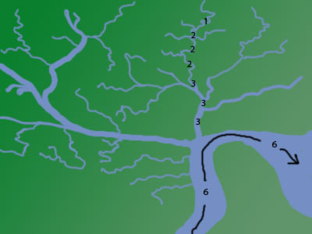
With a few simple rules, you too can learn to count this way. Here are the rules:
- Every headwater stream is a “1”, or as we prefer to say, “first order”. That means nothing feeds into it. In a natural environment it might come from a spring or a seep or a wetland. In an urban environment, it might come from a culvert or a parking lot channeling water to one area.
- Where two first order streams meet, they make a second order stream. Second order streams obviously tend to be bigger and more robust than first-order streams. So far, 1+1=2, but don't get lulled into thinking it will stay that way
- Here’s where it gets tricky. Where a 1st and a 2nd order stream come together, they do NOT make a 3rd order stream. That’s because the 1st order only adds a little water to the larger 2nd order stream. In fact 2nd order streams can get rather large if they keep receiving more and more 1st order streams along their length, until...
- When two streams OF THE SAME ORDER join up, then the stream order increases by 1. So, 2+2=3.
- And two 3rd orders make a 4th order, or 3+3=4.
- But when the 4th order stream enters a largish river (6th order) ... nothing happens. Not to stream order, anyway. The river is still 6th order, because the stream has only added a little water proportionally. The river would have to meet up with another 6th order before it would be promoted to 7th order. In other words, 6+1=6 and 6+2=6 and so on, all the way until 6+6=7.

Stream order
Try it yourself! Remember, streams only change order when they meet another stream that's just as big...
The online version of this module contains an interactive applet which allows you to number streams. To find this applet go to: http://www.mathbench.umd.edu/modules/environment_watersheds/page02.htm | 
What order do you think these rivers are at their mouth?
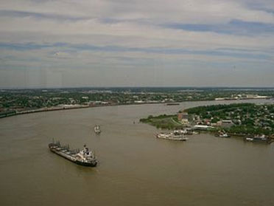  10th order | 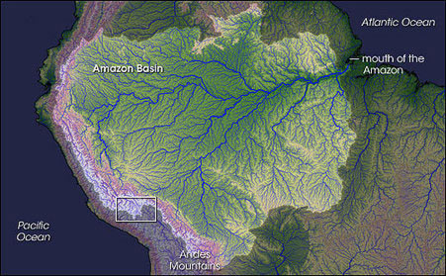  12th order

Outlining a watershed
The online version of this module contains an animation which shows a watershed. To find this applet go to: http://www.mathbench.umd.edu/modules/environment_watersheds/page03.htm | 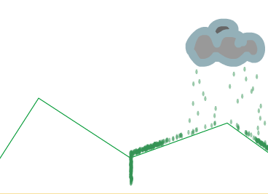
Basically, a watershed is all the land that contributes water to a given stream or river. So in the animation above, we are looking at the cross-section of a watershed (shaped like a V) in the center, and bits of the watersheds on the left and right.
Since a watershed is defined by the point it drains to, watersheds are nested inside each other. For example, the College Park Campus is part of the Paint Branch Watershed. But Paint Branch joins the Anacostia River, so the Paint Branch Watershed is nested inside the Anacostia Watershed, which is itself nested inside the Chesapeake Bay Watershed. The Chesapeake Bay Watershed is not nested inside any other watershed, though – its outlet is the Atlantic Ocean.
It is surprisingly easy to outline a watershed – you just look for the first order streams and make sure you draw a line that goes around them. You can see this if you mouse over this image:
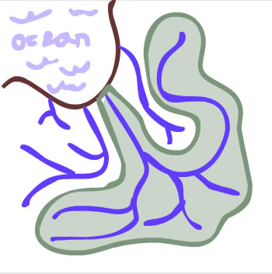
The online version of this module contains an interactive applet which allows you to draw a watershed. To find this applet go to: http://www.mathbench.umd.edu/modules/environment_watersheds/page03.htm | 

Outlining the Bay
Now that you know a little of stream order and finding watershed boundaries, you are ready to find the Chesapeake Bay Watershed. Kind of like hide-and-seek without the hiding part.
The online version of this module contains an interactive applet which allows you to draw the boundaries of the Chesapeake Bay watershed. To find this applet go to: http://www.mathbench.umd.edu/modules/environment_watersheds/page04.htm | 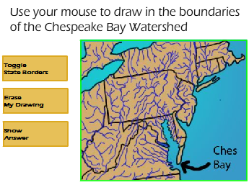
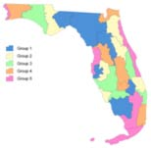
As watersheds go, the land area of the Chesapeake Bay is quite large. For example, here is a map of the watersheds in Florida, drawn to the same scale:
There are 130 estuaries in the US – places where salt and fresh water mix – but the Chesapeake Bay is one of the most productive. Estuaries are incredibly important because the habitat diversity (fresh and salt water) supports a very high biodiversity. In fact the Chesapeake Bay supports about 350 species of fish and 170 species of shellfish.
The Bay is also incredibly productive, producing about 100 times as many fish as average ocean. In fact, humans harvest about 100 million pounds of seafood from the Bay every year, plus another nearly 300 million pounds of Menhaden – a small, oily fish used for fertilizer.
Finally, the Chesapeake Bay is shallow – the average depth is only about 21 feet (just a little more than the deep end at your local pool). And the watershed itself is one of the largest in the US, so that means a lot of land is influencing a little bit of water. In fact our very own Chesapeake Bay has a bigger land-to-water ratio than any other bay anyplace in the world, and by a very long shot. The runner up is the Gulf of Finland, which has 7 times more water-per-land than we do.

What enters a watershed?
As we saw earlier, every drop of rain that lands within the Chesapeake Bay Watershed ultimately flows toward the Bay. (Of course, some of it may not get as far as the Bay – it could get evaporated, or pulled out of a river to be used for an industrial process, or pumped into a swimming pool, but in principle it flows towards the Bay).
But a lot of other things get washed into the Bay with that rain. Trash, for example. Salt and sand from road treatment in the winter. Oil that drips from cars. Dirt, sand, and silt from construction sites. Those things are easy to see, but others are not.
When farmers fertilize their fields or spray pesticides to kill weeds or insects, large amounts of those substances wash off and end up in the water. But its not just farmers – homeowners do the same things, and so do golf courses and landscaping firms. Pesticides that kill plants or animals on the land will do the same thing in the water. But what about fertilizer, why is that a problem?
Fertilizer is essentially food for plants – and just like too much food makes a person overweight, too much fertilizer can put a natural system out of balance. So when fertilizer enters the Bay, algae grows, sometimes in huge clouds or blooms. Sometimes the algae itself is harmful, but usually the harm occurs when the algae dies. All that dead algae causes decomposing bacteria to have a population boom, and the bacteria use up all the oxygen in the water.
Basically the streams act as a huge sewer system, collecting everything discarded or washed away within the watershed. Even pharmaceuticals end up in the stream. In many urban streams, there is a detectable level of birth control drug, a morning pulse of caffeine, and a fingerprint of illegal drugs in the water.

Paving the watershed
So when it rains, things get washed into the watershed. That's good as a general principle, but we can refine it a bit.
If the land around the stream is filled with grass, bushes, or trees, and the soil is not packed down, then lots of water will soak in, or "infiltrate" into the ground. This is good because the soil acts like a natural filter, cleaning out the water before it gets to the stream. It also acts like a sponge, holding onto the water so that it doesn't all rush into the stream like a fire hose.
But when rain falls on a street, parking lot, or sidewalk, it can't soak in. Instead it flows very quickly into the stream or into nearby storm drains.
Ever wonder where those storm drains go? Mostly, they go directly into the nearest stream, along with any dirt, trash, pesticide, oil or other pollutants it might happen to encounter. Paved surfaces that prevent rainwater from naturally soaking into the ground are called impervious surface, or IS for short.
Pollution from impervious surfaces is linked directly to land use. This is especially true in the areas right around a stream or river, called the buffer zone.
Even 15% impervious surface in the buffer zone may cause serious water quality problems. Water enters the stream quickly, causing erosion. It carries with it dirt, toxic chemicals, and trash. And the hot surfaces of the pavement heat up the water, delivered a kind of heat shock to the stream.

Sampling pavement
In order to find out how much impervious surface is in the watershed, we use presence/absence sampling. In other words, we pick a lot of random points, count the number that are impervious, and then calculate a percentage.
Below, you can get some practice estimating impervious surface using the presence-absence method. Don't worry, the program will do the actual counting. All you need to do is tell it to take samples, and then decide when enough samples have been taken.
The online version of this module contains an interactive applet which allows you to estimated impervious surface. To find this applet go to: http://www.mathbench.umd.edu/modules/environment_watersheds/page07.htm | 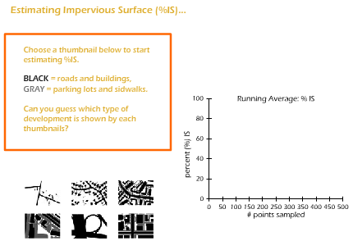
Now consider that the University of Maryland campus has > 60% impervious surfaces. How healthy do you think streams in this area are?

Muddying the waters
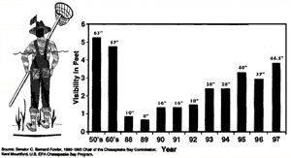
There are many ways of measuring water quality in the Chesapeake Bay (or anywhere else). For example, measuring the clarity of the water is an obvious way to figure out, very roughly, how much “stuff” is in it. For the last 150 years, people have been doing this with the help of a “secchi disk”, You lower this black and white disk into the water and measure the depth at which the disk can no longer tbe distinguished.
A secchi disk is decidedly low tech, although recently a Chesapeake Bay activist named Bernie suggested an even more intuitive measure called “Bernie’s toes” – the depth at which he could no longer see his own feet.
Another way to measure water quality is to take bay water and mix in particular chemicals which will react with specific pollutants such as excess nitrogen (fertilizer). This allows you to measure levels of specific pollutants and possibly guess where the pollution is coming from.

Model organism for contamination
Another way to measure water quality is to look at what’s living in the water. You could count fish or oysters or insects. For example, one famous measure is to find out how many stoneflies, mayflies, and caddisflies are living in a stream—all insects that require cold clean water, and all gourmet food for the kinds of fish that anglers like to go after. But in this module, we’re going to do something a litle different.
We’re going to talk about measuring an undesirable organism that we can’t see. The organism is called Enterococci faecalis, or E. faecalis, and it is a spherical bacteria that primarily lives in the guts of vertebrates, where it does no harm and may actually help us to digest food. It can be ... um ... excreted from the body and from there it can get washed into the water.
Humans generally use a sewer system to do their excretion, but most other animals don’t. A dog-walking park next to the creek could result in a creek full of enterococci, unless the dog-walkers are very good with their pooper-scoopers. So can a cow pasture, a chicken house, or a pig farm. But once the enterococci get into the water, they generally can’t reproduce very well. Instead, they just sit there, usually not causing any problems for anyone, but also being a great way to determine how much pollution is in the water.
In order to use Enterococci as an indicator, we need to filter them out of the water, provide them with really good growing conditions, and see how many little colonies form after a day. Each colony will be visible to the human eye, and each one started from a single bacteria, so counting the colonies will allow us to estimate how many bacteria were present in the water to start with.

Just how many enterococci are in the Bay?
Before we start actually measuring things, let’s think about how we could make some estimates. Specifically, how could we estimate how many enterococci are in the Bay right now?
Wow.
Personally, I deal with this stuff every day, and I still have no clue. So don’t think it’s some kind of trick question. Here’s what I do know:
- “Good” water quality is 20 cells per 100 mL of water, while “bad” is anything over 200.
- A cubic meter of water is the same as a cube of water that is 1000mLs on each side.
- The average depth of the Bay is 21 feet.
- The great physicist Richard Feynman has championed this kind of estimation problem for building scientific intuition (ok, I know that wasn’t directly helpful, sorry).
So... where do we start? If we knew how much water was in the Bay, we could use that to estimate the range of enterococci depending on water quality. So, how can we figure out how much water is in the Bay?

How big is the Bay watershed?
- The Bay watershed stretches from upstate New York to Virginia, which would take about 8 hours to drive, so it must be...: about 500 miles
- Let’s convert that to metric right away. A quick google search shows me that 1 mile = 1.6 kilometers, so that’s...: about 800 km
- the watershed is about a third as wide as it is long, so that’s ...: about 300 km
- making total watershed area ...: about 240,000 km^2
Certainly we could have looked up the watershed area, but we're probably within a factor of 2, which is pretty good for an estimation problem.

What's that in square meters?
- We have to multiply km^2 by (1000*1000) to get m^2: that's a lot of zeros!
- Let's try the trick of tens: 240,000 * 1000 * 1000 is the same as : 24 with 10 zeros
- Or scientific notation: 24 * 10^10 (m^2)
OK, now we have an estimate for the land area in the watershed, but what about the area under water? It's a lot smaller...

So how much water is that?
- Maybe 1% of the watershed is actually under water, so that would be 24 with 8 zeros, or...24 * 10^8 m^2
- The average depth of that water is 21 feet, which is (in metric)...about 7 meters
- So the volume of water (area * depth) is about...200 * 10^8 m^3
- Remember that a cubic meter is 1000mLs on each side, so to convert to mLs we have to multiply by 1000*1000*1000
- which gives us... 200 * 10^17 mLs
- or in English... 20 million trillion
So let's get a range, depending on whether water quality is good or bad.

So how many enterococci already?
- If water quality is good, say 10 enterococci / 100 mL, which is the same as 1 per 10, so that's...2 million trillion
- If water quality is bad, say 200 enterococci / 100 mL, which is the same as 2 per 1, so that's...40 million trillion
There are a couple of things to notice about these calculations.
First, I was awfully cavalier with the numbers, rounding pretty much whenever I felt like it. And actually, this is OK – because none of these numbers are very exact in the first place. It would be pretty silly to carry out calculations to 5 decimal places when I don’t even know whether the average number of enterococci is closer to 10 or 200 ... when the volume of water in the Bay is fluctuating all the time with the rainfall ... when I don’t even know exactly how big the watershed is.
Secondly, scientific notation becomes almost a necessity. Otherwise it would be really hard to keep track of all those zeros. And, unlike rounding, adding or dropping a few zeros WOULD make a huge difference in the final answer. Luckily scientific notation gives us an easy way to count the zeros.
So just how accurate is 2 to 40 million trillion? My professional estimate is “within a couple orders of magnitude”. That means I think the real number is somewhere in the million billions. And that’s as close as I can get with estimation.
For a point of comparison, there are about 100 trillion bacteria living in your body right now, so 2 million trillion is not really all that far-fetched...

Where are the enterococci coming from?
Here’s another fun fact. There are about 10 million enterococci in every gram of human feces.
Let’s assume that this number is representative of other vertebrates as well. So how many kilos of feces would be needed to put 20 million trillion enterococci into the Bay?

How much poop is that already?
- 20 million trillion divided by 10 million is...2 trillion grams
- Or in kilograms...2 billion kilos
- Or in tons (2000 kilos)...1 million tons
According to Tom Horton in Turning the Tide, about 44 million tons of manure are produced in the Chesapeake Bay watershed every year -- 100+ pounds per day per cow, 20 pounds per pig and another 4 oz per day per chicken. So, again, its not too far fetched to think that 1 million tons of that ends up in the water.
Of course, manure doesn’t get dumped directly into the water, not legally at least. But today’s industrial farming operations make large amounts of manure unavoidable. Typical farms in the late 1990s had about 60 cows, 300 hogs, or upwards of 100,000 chickens, concentrated on relatively small acreages. Where does all this manure go? Some of it can be spread on fields, but in cold or rainy weather, that creates more runoff. Storage pits, or lagoons, can hold manure until it can be spread, but these lagoons are also vulnerable to leakage or overflow.

How do microbes grow?
As I said before, Enterococci prefer to live inside of someone’s gut. There they have ready access to a nice warm body temperature, and they are bathed in a sugary broth of nutrients.
Nevertheless, enterococci are nothing if not flexible. They can survive water temperatures from a cool autumn day to hot summer. They can digest amino acids (the building blocks of protein) as well as starches and sugars. They can live with oxygen or without it (therefore they are called facultative anaerobes – they have the facility, but not the necessity, of living anaerobically – without oxygen).
In other words, enterococci thrive in your gut or in a petri dish, but in most other environments, they just hang out, neither dying nor reproducing much. Because of this useful skill, enterococci have become the official sponsors of the US Environmental Protection Agency water quality testing. What I mean is, they are the microbe officially used by the EPA to measure contamination of water.
And we’re gonna make like the EPA, and use enterococci to test our waters as well.

A day in the life of a microbe
In most streams and rivers, enterococci are limited by temperature and nutrients, and they don’t grow much. Another way to say this is that for enterococci, nutrients and temperature are limiting factors. In order to test water quality by counting enterococci, we need to do two things:
- take away limiting factors for enterococci in our sample, and
- make sure that any other microbe that might be in the water still has limiting factors.
It’s important to keep (or even add) limiting factors for the other microbes, because otherwise we’ll be counting all sorts of bacteria in addition to enterococci, and our data won’t be valid. We do this by using a selective media – in other words, a gel-like food which is also laced with antibiotics and various other chemicals to limit all the other microbes. (One of the reasons that enterococci make such a good test case for contamination is that it is NOT affected by antibiotics which knock out most other microbes).
So, let’s watch a single enterococcus cell, who happens to be sitting next to a couple of staphylococcus cells. Because of the antibiotics, the staph cells will quickly get disabled, but not the enterococcus (let’s call him Rocky for short). In fact, after spending weeks in a (to him) cold and barren creek, Rocky is finally living the good life. He is surrounded by lactose sugar (yum!) and nice and warm.
Rocky pulls in sugar as fast as he can, and soon he’s grown out of his membrane. He splits in half, creating little Rockies 2 and 3. These two guys also pull in sugar as fast as they can, and xx minutes later, they too start to feel ready to split, so they do. Rockies 4, 5, 6 and 7 keep going.
time: 0 min  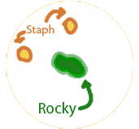 | time: 50 min   | time: 1 hr 40 min   | time: 2 hrs 40 min  
Of course, none of the Rockies has a way to move, so they’re stuck sitting in a little pile, but they don’t mind, because there’s plenty of sugar to go around. Pretty soon we have a pile consisting of Rockies 8 through 15. And so on.
Eventually (after about 24 hours) this pile will be big enough for one of us hulking human beings to see without even using a microscope. This tiny but visible pile is called a colony, and the original Rocky was the original colony-forming unit, or CFU.
Of course Rocky was probably not the only CFU around. Over on the other side of the gel Terry was sitting around, minding his own business, enjoying the warmth and sugar, and growing at the same rate. So while a few million descendants of Rocky formed a colony on one side of the plate, a few million descendants of Terry form a colony of the other side. And so on, one colony for each original colony forming unit.

Building the growth equation
As we just saw, bacteria multiply by dividing, so to speak. A single bacterium grows and lengthens, and then divides into 2. Those two "daughter" cells eventually divide in 2. And so on.
Starting with one cell dividing in half, the resulting microbe populationswould look like this:
# in gen0 --> 1
# in gen1 --> 1*2
# in gen2 --> 1*2*2
# in gen3 --> 1*2*2*2
# in gen4 --> 1*2*2*2*2
Instead of writing "# in gen 4", it is more usual to write N(4), which you can read as "the number in generation 4". Likewise, for the general equation we write N(t), or "the number in generation t". So, given the formulas above, which of the following is the correct equation for exponential growth starting from a single cell?
N(t) = t * 2^{t} | N(t) = 1 * 2t | N(t) = 1 * 2^{t} | N(t) = 1 * t²
no -- otherwise N(3) = 3 * 2*2*2 = 24 | no -- otherwise N(3) = 1 * 2*3 = 6 | yes -- for example, N(3) = 1 * 2*2*2 = 8 | no -- otherwise N(3) = 1 * 3*3 = 9
With a few more changes, we can make this look more official.
- Most importantly, we may not be so lucky as to start with one single, solitary cell. The culture could start with 2, or 7, or 10,000. Instead of the initial population being 1, let's call it N₀, pronounced "n sub zero", meaning "the number of cells in generation 0".
- Less importantly, I removed the multiplication sign - it's still there, just invisible.
Our final equation looks like this:
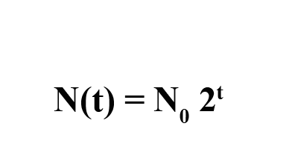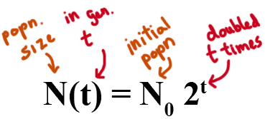

Visualizing the growth equation
The online version of this module contains an interactive applet which allows you to draw an exponential curve. To find this applet go to: http://www.mathbench.umd.edu/modules/environment_watersheds/page03.htm | 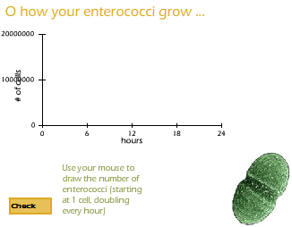
Graphs of exponential growth always curve upwards, like this one. Now see if you can figure out approximately how many cells are in the little "pile", or colony, that we count on a plate after 24 hours.

How many cells result from a single CFU after 24 hours. (Remember, the doubling time for E. faecalis is about 50 minutes in the lab).
- how many times do the cells double... : 24 hours * 60 minutes = 1440 minutes. <br>1440/50 = about 29
- if you double 29 times ... :it's the same as 2^29

Answer: 2^29 = about 500 million
So that means when each colony you count on a plate consists of as many as 500 million E. faecalis cells....

How do we count them all?
Luckily for us, we don’t need to count all of those millions of descendants of Rocky and Terry and all the others. All we care about is counting the original colony forming units, or CFUs. In other words, just the original Rocky and Terry. And we can do this because Rocky left a pile of descendants, and Terry left a different pile someplace else.
So, that becomes our basic modus operandi:
- get a sample of water, and keep it cold, so that the enterococci will not reproduce
- put the sample on a plate, getting rid of all the water, so just the CFUs are left
- let the CFUs on the plate grow and multiply in comfy conditions for 24 hours.
- 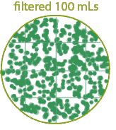count the colonies.
The hardest part of all of this is keeping really clean so that so your results are valid. Otherwise its not hard to understand. But there is one wrinkle. We need to count the number of CFUs per 100 mL of water, but we don’t know if advance how many there will be (duh! otherwise we wouldn’t need to count them!!) Let’s say there is an infestation of enterococci (400 per 100mL of water). If you filter 100 mL of water and plate the sample, after 24 hours, your plate will look something like this:
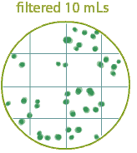
And you won’t want to count that mess!!
So, one solution is to filter only 10mLs of water. Let’s say you did that and got a plate that looked like the bottom plate:
How many CFU’s are on this plate?
39
How many CFU’s would there be in 100mL: 390

What if your water has very little infestation?
So far so good. If you have a high infestation, you're better off counting the 10mL plate. But what if you have water with almost no infestation? Then your plates might look like this:
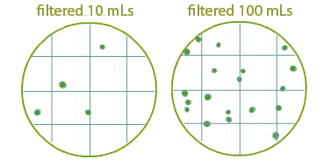
Well, the 10mL plate is easy to count, but maybe not too accurate. If you happened to get just a few more CFUs, it would look like your contamination rate doubled! So you’re better off filtering 100mL of water. Then an extra CFUs won’t make too big a difference.
For these 2 plates, we would estimate contamination as
40 CFU per 100 mL
19 CFU per 100 mL
So we should filter 10 mLs if we have lots of enterococci and poor water quality, but 100mLs if we have few enterococci and good water quality. The only problem is, we don’t know in advance which one its going to be...

Pick your plate
So it looks like you could solve the whole problem by filtering large amounts of clean water, and small amounts of contaminated water. BUT... sadly we can’t know just by looking which is which. So the safest route is ... do both! Filtering is quick and easy, compared to needing to go back for extra samples. When you see the plates, then you decide.
Let’s try it. In each box, you’ll see the results of filtering and plating 2 samples from the same water body. The first was a 10 mL sample, and the second plate was a 100 mL sample. Which plate should you count? Remember, you want the counting to be easy, but not so easy that you’re sacrifiing accuracy. The rule of thumb is 20 to 60 colonies per plate make a good sample.
Once you pick your plate, what is the contamination level is CFU per 100 mL?
The online version of this module contains an interactive applet which allows you to practice counting plates. To find this applet go to: http://www.mathbench.umd.edu/modules/environment_watersheds/page17.htm | 

Putting it all together
It’s time to put it all together and use what’s you’ve learned about watersheds and water quality.
- Predict which of these 3 sites will the worst water quality
(>400 cells / 100 mLs).
- Confirm your prediction by sampling and counting enterococci.
- Identify the factors that affect water quality at each site.

Think carefully about where sources of contamination might be coming from, the amount of impervious surface, and the size of the stream. When you make your prediction, check it in the applet below.
The online version of this module contains an interactive applet which allows you to practice counting plates. To find this applet go to: http://www.mathbench.umd.edu/modules/environment_watersheds/page18.htm | 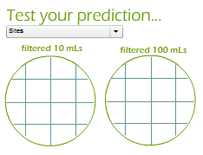
So were you right? What do you think each of the factors had to do with water quality?
Sources of contamination: The farm has the highest sources of contamination (animal manure), but the residential developement probably has a lot of dogs and cats doing their thing outside too. The golf course probably has the lowest -- just squirrels. And remember, we/'re only measuring bacterial contamination. The townhouses and golf course are polluting with pesticides and and other chemicals, but that/'s not what we/'re measuring.
Stream size Two of the sites were second order. That would mean there was more water diluting the effects of any contamination. In general first-order streams are more susceptible to all kinds of contamination.
Impervious surface. The farm and golf course had the lowest impervious surface, while the townhouse development had the highest. So in this sense the townhouses are more damaging
Overall The farm had two problems -- huge input of contaminants, and small volume of water. Even though the watershed was not paved, this site probably will have the worst water quality.

