
Cell Processes:

Diffusion through a membrane

URL: http://mathbench.umd.edu/modules/cell-processes_diffmembrane/page01.htm

Note: All printer-friendly versions of the modules use an amazing new interactive technique called “cover up the answers”. You know what to do…

Equation déjà vu
In this module, we'll learn something about osmosis, potential differences, and pressure gradients, but we'll also talk a lot about discrete vs. continuous equations, and algebra vs. calculus.
Continuous equation | Discrete equation
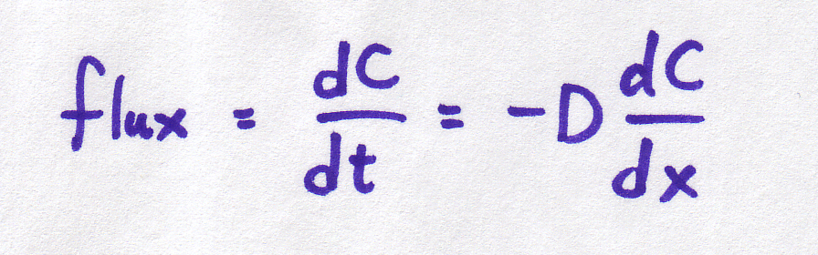 | 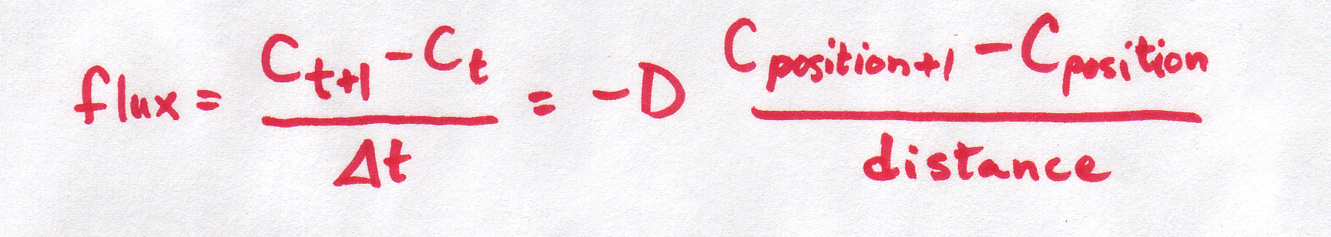
It is important to understand that BOTH of these equations refer to the same basic phenomenon -- particles moving at random, with the net result that particles move from areas of high concentration to areas of low concentration. And BOTH of these equations describe what's happening in the same way -- the concentration gradient is defined by the difference in concentrations per distance between them.
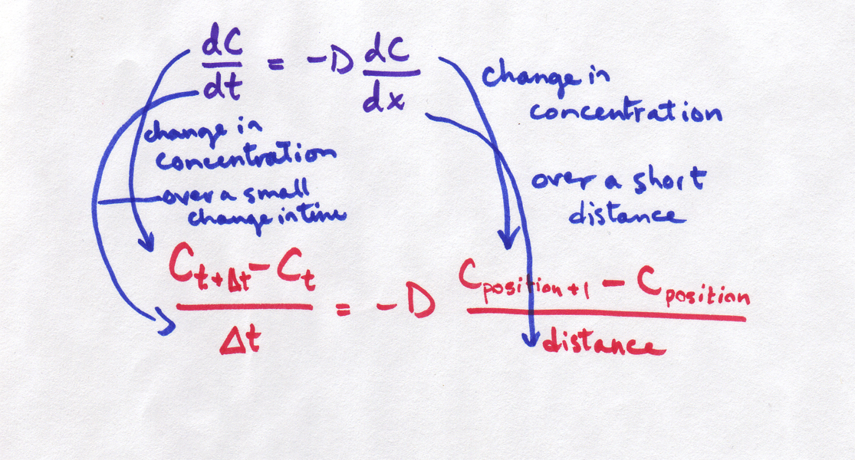
So why are we using two different equations for the same thing??? Sometimes, a discrete equation is an "easier" version of a continuous equation, and sometimes it's the other way around, the continuous is an "easier" version of the discrete. In this case, the discrete is easier, but the continuous is more realistic. The discrete is an approximation or simplification of reality. The discrete equation tells us a lot about the process without needing to get involved in the truly messy kind of math required to work with the continuous version (which require partial differential equations -- look them up if you want to know more!).

Simplifying the situation
But first, back to biology. We're going to talk about what happens when you have a concentrated solution (think sugar water) and a less concentrated solution (think distilled water). Remember that in the diffusion module, we were talking about the diffusion happening in a sort of imaginary tube, like this:
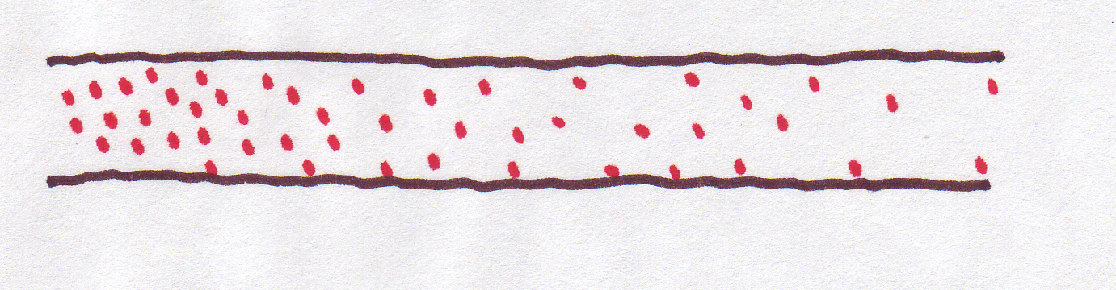
That's why we talked about concentration at "positions" along the tube. But in this module, we simplify the situation: just two sides of membrane -- inside and outside, or left and right. Right and left is a lot easier to deal with than a spectrum of possible positions.
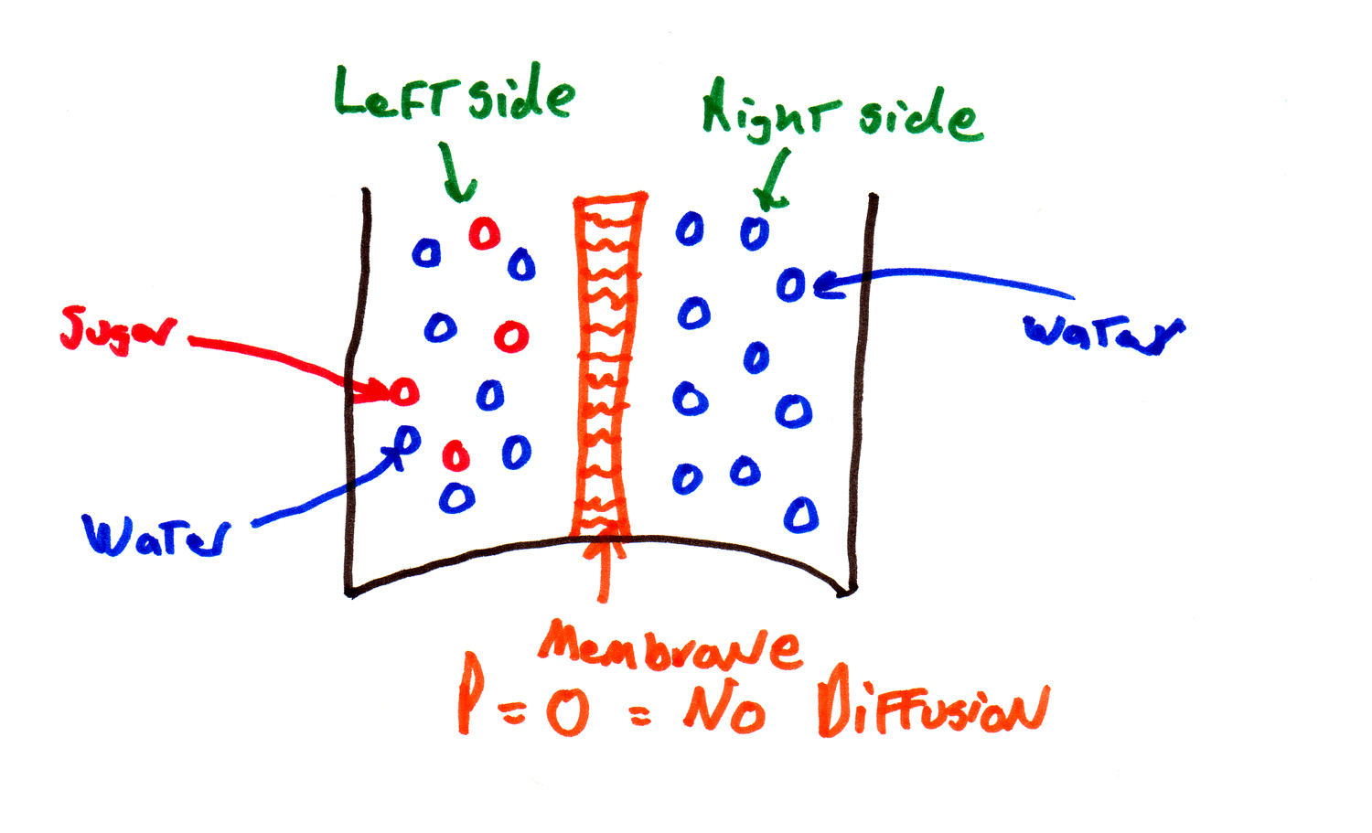
Here are a couple of other assumptions we need to make about the state of the system (think of this as the legal fine print):
1. the solutions on both sides of the membrane are homogeneous. By this we mean that the solute is evenly mixed so there is no active diffusion taking place within a side.
2. the membrane is not changing width, so the distance between the sides is a constant.
This is called the "two compartment model" -- the continuous positions in the original equations are replaced by two compartments, and this is going to make the equations easier to deal with.

What does continuous mean?
Continuous | 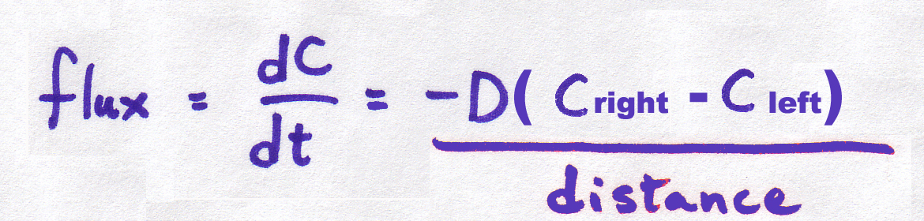

Discrete | 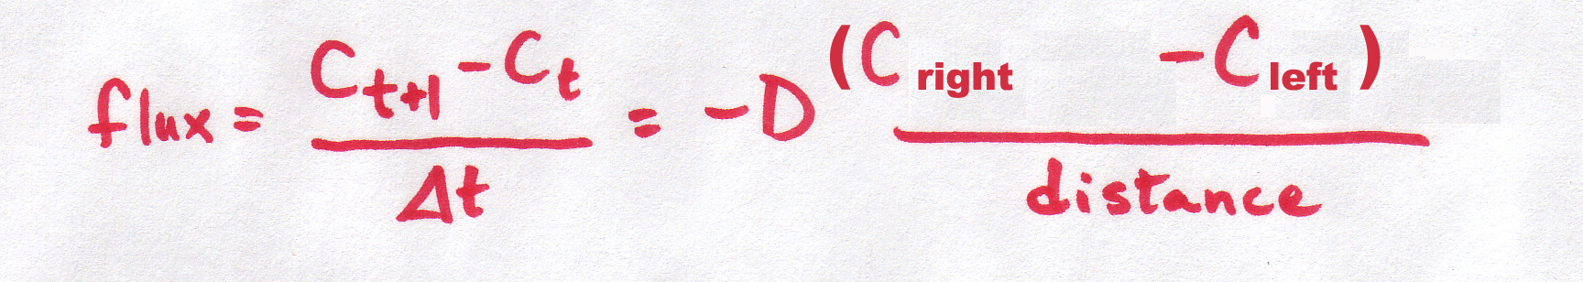
Notice that we replaced the "position+1" and "position" subscripts with "right" and "left", but we haven't changed anything else (yet).
First, SO WHAT DOES CONTINUOUS MEAN ANYWAY?
The old "continuous" equation was continuous over both space (the positions in the tube idea) and time (the rate of diffusion changed gradually).
The new continuous equation will be continuous in time only. It is not continuous in space because we now have only two compartments.
The "discrete" equation is even easier -- it is not continuous in space (remember the 2-compartment model) OR time (the rate of diffusion stays the same for whatever time interval you specify). For example, if you use the discrete equation with 1 second timesteps, the rate only gets recalculated every second, and the graph looks "blocky". This is OK because the rate isn't changing very fast. If it was, the discrete equations which only calculate the rate every one second, might seriously mis-estimate the situation.
We'll continue to develop the equations in both continuous and discrete form, and at the very end of the module, we'll compare their performance.

Thinking about permeability
So far, we've changed the equations to account for the left and the right side of the model, but we still haven't thought about what's in between -- the membrane. Right now, there's a "diffusion coefficient" (D) in there, but what we need is a number to characterize the membrane.
How much solution will flow through the membrane depends on how permeable the membrane is. Some membranes are very leaky, some only let through certain molecules, and some let through virtually nothing.
For instance if the membrane was made of saran wrap, it would block all diffusion -- saran wrap is not permeable:
 | ←  Membrane is totally impermeable to anything  →
If the membrane was made of window screening, it wouldn't block anything -- its completely permeable.
 | ←  Membrane is  completely permeable  → | 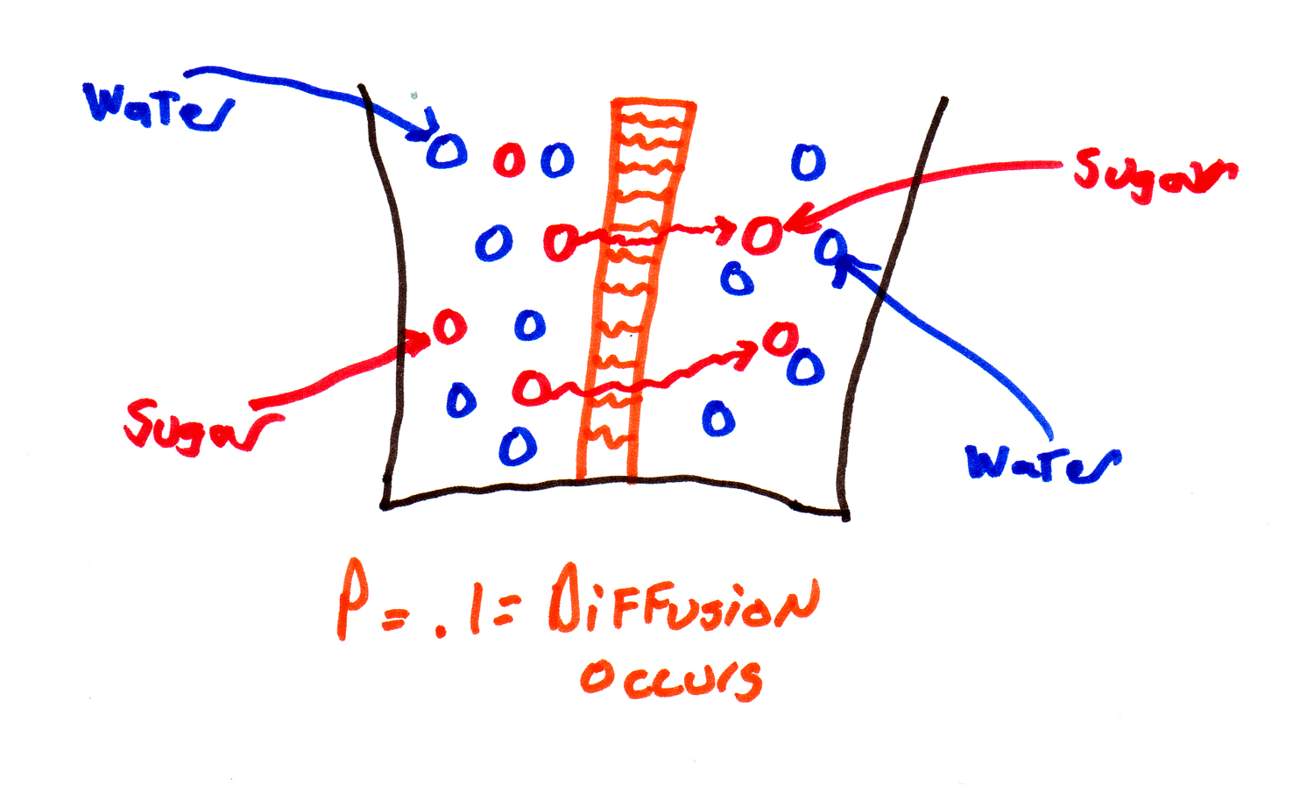
Presumably you could find some substance that was midway between saran wrap and window screening -- something that was partially permeable. This suggests that with a small adaptation, we could continue to use our old diffusion equations (mathematicians LOVE recycling their equations). We could change the diffusion coefficient D into something that accounts for the permeability of the membrane. Let's call that .... P (easy to remember).

Getting personal with P
What is this new measure P and how does it relate to what we had before????
We want to know how much of our sugar is crossing the proverbial border and going into the other side of the membrane. So permeability (P) is going to depend upon 3 things:
1. P depends in part on D (the diffusion coefficient), which is determined by the size of the particle diffusing and the solution being diffused through. All else being equal, particles with a higher diffusion coefficient also have a higher permeability.
--> P increases when D increases.
2. P also depends on the width of the membrane. All else being equal, permeability is higher when the membrane is thinner. (Thus P takes care of the dx or Δx that was in the old diffusion equation).
--> P decreases when Δx increases.
3. Finally, there is a term we can measure and come up with experimentally, called K. Molecules that are "slippery", like lipids, have a high value of K, while charged particles (like the ions from salt) have a low value of K. And K can vary over a huge range, much more so than either P or Δx or D.
--> P increases when K increases.
So now we have a new measurement which is important for diffusion through a membrane P which is.....
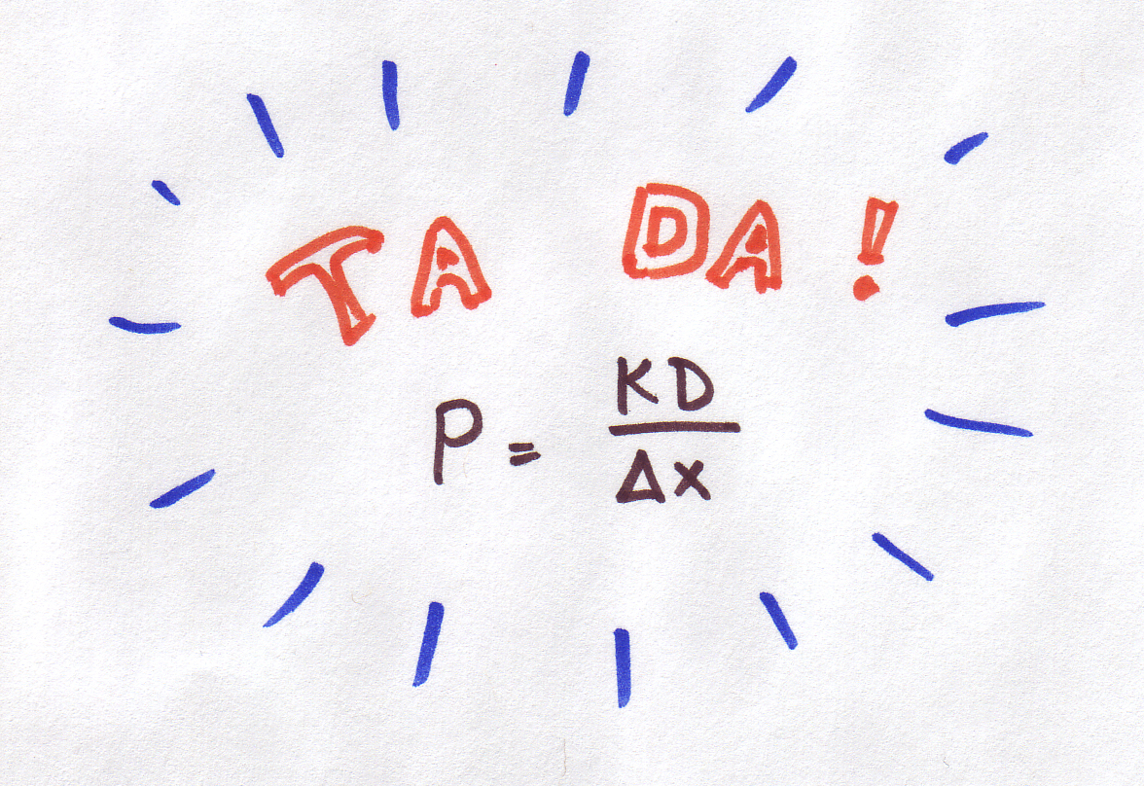
This is the important quantity which will now stand in for just plain old D in our diffusion equations above. (The units of P, in case you have an inquisitive mind, are cm/s).

Assume that the diffusion coefficient (D) is 1 x 10⁻⁶ cm²/sec at 10ºC, and that the membrane is 1 mm wide (0.1 cm),K=0.004. What is P equal to?
- Plugging these numbers into the equation P = ^{kD} / _{∆x}
- P = 0.004 * 10 ⁻⁶ / 0.1

Answer: P = 4 * 10⁻⁸ ^{cm}/_{sec}
In nature, the permeability constant is normally very small, usually around 0.00005, although it can be as high as 4. Notice that its important that you get all the units to match before you do the calculations. For example, if we hadn't converted 1 mm to 0.1 cm, the permeabilities would have been 10 times too high.

The area of the membrane matters
One more thing, before we get too enthusiastic about our new equations. We can imagine a gallon of salt water and a gallon of distilled water with a membrane (the partially permeable kind) between them, and we know that the thickness of the membrane is taken care of as a part of P ... but how wide and how tall is the membrane?? It will make a big difference if the membrane is 1 square centimeter or 1 square meter in area!! In fact, I would be willing to take bets that if the membrane has 10 times the area, it will let 10 times more stuff through (that would be a linear relationship).
This issue becomes pretty important when we start thinking about scaling and things like the surface area of the lungs.
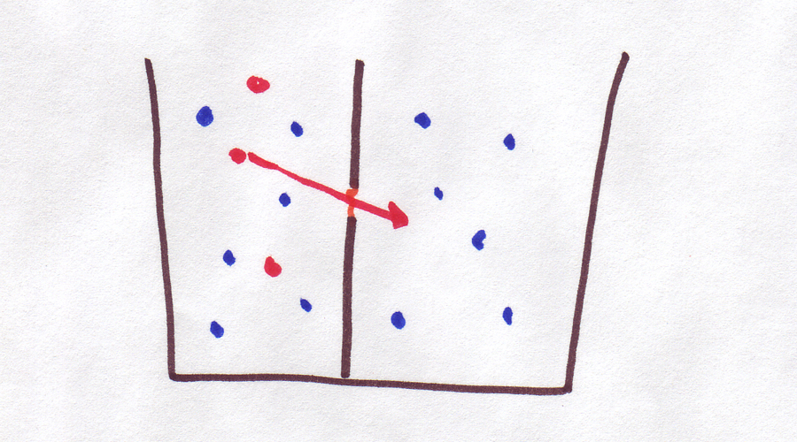 | ←Small Membrane to left  Large Membrane on right → | 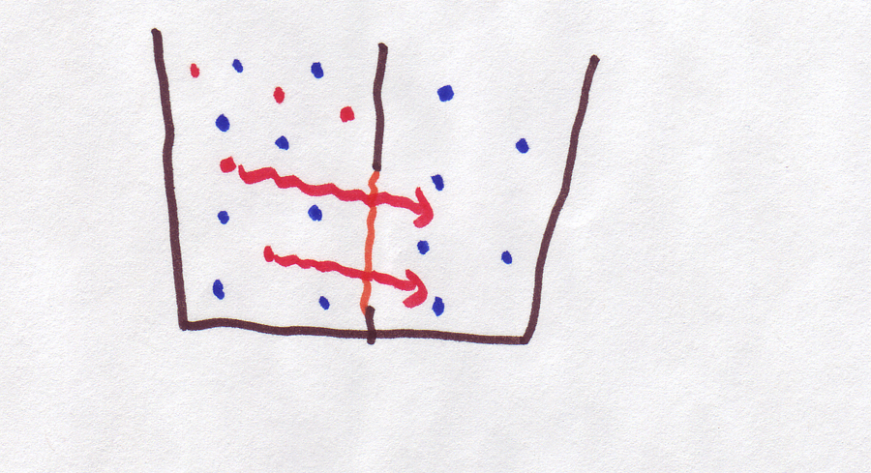

Our equations are ready
So let's add a linear term for area of the membrane. Hmm, let's call it A, for area. No one can accuse mathematicians of getting too fancy with their names. So here are our final (for now) equations:
Continuous version | 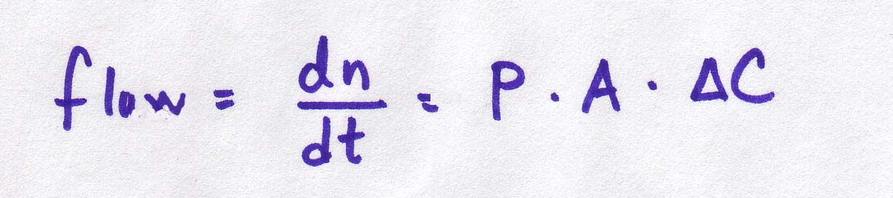 | 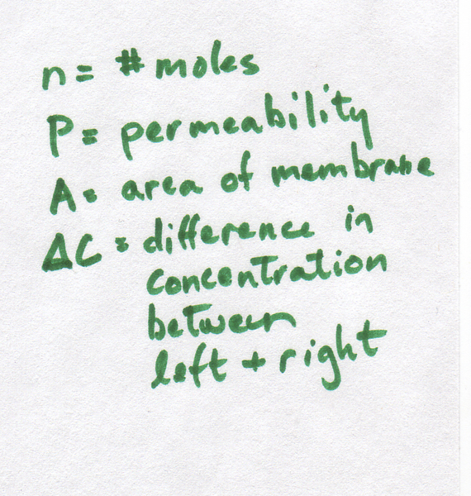
Discrete version | 
In order to do any calculations, we will have to get a handle on the actual values of these variables.
That means we need to be able to measure concentration. You might think this is pretty easy. For example, if you put 100 grams of sugar in 900 grams of water, you will have a solution that is 10% sugar by weight. And you probably don't want to try to drink it. (Honest, even Mountain Dew is only about 8% by weight).
However, unfortunately, diffusion doesn't care about weight, it cares (if a process can be said to care) about particles . How many particles of sugar were in that 100 grams?
Before you get out a magnifying glass and start counting sugar grains, let's be clear about what a particle is: as a first approximation, a particle is a molecule. So, you need to know the molecular weight of sugar C₆H₁₂O₆.
If you remember how to calculate molecular weight, go ahead and do it now. If not, the next page is just for you...

Quick refresh: atomic/molecular weight
A quick refresher on atomic/molecular weight: if you look at a periodic table, every element has an atomic number and an atomic weight. The atomic number tells you how many proton an atom has, and the atomic weight gives you the average weight of an atom (including protons and a range of possible numbers of neutrons). So, no matter how your periodic table is organized, the atomic wieght is the larger of the numbers listed in the element's box.
By definition, one mole of an element weighs the same (in grams) as the molecular weight.
For those of you who are thinking, hold on, what's a mole ... a mole is a more convenient way to count up molecule. As everyone knows, your average fist-sized object contains a billion-gazillion molecules, which makes them rather inconvenient to count. So instead, we talk about a "mole" of molecules, which means 6.022 * 10²³, or about 60 trillion trillion. Kind of like a "dozen" eggs, but a much bigger number.
So anyway, one mole of carbon is the same as 60 trillion trillion carbon atoms and weighs all of 12 grams. Likewise, a mole of hydrogen weighs a paltry 1 gram, and a mole of oxygen tops out at 16 grams. (We're rounding a little here, which is no big deal).
To get a single glucose molecule (C₆H₁₂O₆), we need 6 carbon atoms, 12 hydrogen atoms, and finally 6 oxygen atoms. Likewise, to get a mole of glucose, we need 6 moles of carbon, 12 moles of hydrogen, and 6 moles of oxygen. All of this weighs
6*12 + 12*1 + 6*16 = 180 grams So, the molecular weight (or weight of a mole) of sugar is 180g.

The chemical formula of caffeine is C₈H₁₀N₄O₂. Using the periodic table excerpts from below, what is its molecular weight?
- A caffeince molecule has 8 carbon atoms and each weights about 12 g/mol.
- Add up the weight of each atom type separately.

Answer: 8 * 12 + 10 * 1 + 4 * 14 + 2 * 16 = 194 g/mol

Detour: converting grams into moles
Now that we know the molecular weight of sugar (180 g), how can we use that to convert grams of sugar into moles of sugar? Stop me if you've heard this one before...
Step 1: Make a conversion fraction. Here's an example: ^{1 mol}/ _{180 g}. What's a conversion fraction? It's a fraction where the numerator + denominator are equal, and therefore the value of the fraction is 1. However, the numerator and denominator are expressed in different units, so the fraction can be used to convert a measurement. How do you do that? Go to Step 2.
Step 2: Do a test to see if you can multiply your original measurement by the conversion fracton, like this:
100 g sugar * 1 mol sugar / 100 g sugar
Notice how you can cancel the "grams" units to get 100/180 mol sugar, or 0.56 moles. Cool! You're done.
Step 3: If step 2 didn't work, you would need to "flip" your conversion fraction, which is OK since the top and bottom are equal:
100 g sugar * 180 g sugar / 1 mol sugar
So if you make the convertion fraction wrong, you can fix it here.
Finally, we can find the concentration of our sugar goo by dividing the moles of glucose by the volume of water in liters (900g of water has a volume of 0.9 L):
Concentration = 0.56 moles / 0.9 L = 0.62 ^{moles}/_{L}
Voila, if you put 100g of glucose into 900mL of water, you have a solution that is 0.62 ^{moles}/_{L}, often abbreviated 0.62M.

100 g of caffeine is how many moles?
- The molecular weight of caffeine is 194 ^{g}/_{mol}
- In order for the units to cancel out, the conversion fraction needs mole on top and grams on the bottom.

Answer: 100 g * 1 mol / 194 g = 0.5 mol

And 100 g of CO₂ in moles?
- The molecular weight of C and O are 12 and 16. The molecular weight of CO₂ = 12 + 2 * 16 = 44 g
- In order for the units to cancel out, the conversion fraction needs mole on top and grams on the bottom.

Answer: 100 g * 1 mol \ 44 g = 2.3 mol

Detour: practicing conversions

And what you've all been waiting for
Here's another kind of possible problem: Using the equation governing the flow of sugar across a membrane from the following equation
And given that
P= 0.02 cm/sec
the area of the membrane between the two solutions is 2 cm²
Solution left side of the membrane = 0.4M
Solution right side of the membrane = 0.1M
What is the rate of diffusion across the membrane for the following concentrations? This kind of problem requires straightforward plug-and-chugging...
0.02cm/sec x 2 cm² x (0.4M sugar - 0.1M sugar) = 0.012 moles/second
What would happen if we doubled the permeability constant? | the flux would double
What if we doubled the area of the membrane? | the flux would double
What if we doubled the concentration on the left? | the flux would NOT double. Instead, the difference between the left and right sides would increase from 0.3 to 0.7, so the flux would slightly more than double.

Review

We're going to quickly summarize the module, and then do one final (slightly extended) example using these equations, and comparing the performance of the continuous and the discrete models.

The diffusion through a membrane equations: diffusion is driven by the difference in concentrations on the two sides of the membrane. It is also affected by the permeability coefficient and the area of the membrane:

The permeability coefficient is determined by the equation P = KD/Δx.

The concentrations that we need in order to calculate flux are in moles/liter. A mole is 6.022 * 10²³ molecules (sixty trillion trillion).

In order to convert between grams and liters, you need to know the molecular weight of the substance, which is to say, how much a single mole of that substance weighs. Molecular weight is calculated by multiplying the number of times each type of atom appears in the equation by its molecular weight, and adding it all up.

Multiplying grams by molecular weight will give you the number of moles of the substance. Then dividing by the volume of water will give you concentration in moles/L.

Moles per liter is sometimes called simply M.

A metaphor

And now for the extended example comparing continuous and discrete equations.

Here is a metaphor for continuous and discrete equations: Imagine you are driving down a country road in Iowa -- the road is mostly flat, straight, and empty. You are doing all the things you learned in driver ed, continually checking the road and your mirrors. You compensate immediately for any change in driving conditions. You are operating in a continuous mode. However, you start to get bored. So, seeing as the road is nice and straight, you decide to catch up on some reading. Here's the new strategy: glance at the road to make sure you're headed in the right direction, look down at your book for 5 seconds. Glance up at the road again to readjust. Read for 5 more seconds, and so on. You're in discrete (or discontinuous) mode, and everything's peachy. Your Δt, the amount of time between readjustments, is 5 seconds, as opposed to when you were continuously checking the road and your Δt was infinitely small (called dt).

But in a surprising geographic twist, suddenly the road becomes twisty, with cliffs on one side. And suddenly, your DISCRETE strategy of glancing at the road every 5 seconds doesn't seem like a great idea. You might glance up just before a curve and make a sharp right, but you don't see the following sharp left and go sailing off the cliff. Or you might glance up and see a straight patch ahead but fail to notice the sharp right ahead, so you go smashing into a wall of rock. In any case, you'd better decrease your Δt (look up more often) or better yet, go back to continuous mode!

Continuous curves
In the same way, a continuous equation constantly "checks" its variables to see which direction it should be heading (on a graph, rather than a road). A discrete equation only checks every once in a while, every Δt to be specific.
Here is a graph of the solution to the continuous model:
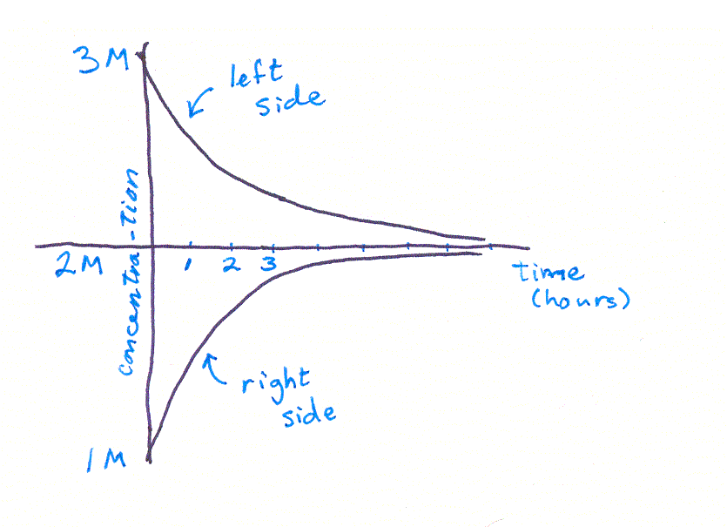
This graph shows the concentration of particles on the left and right sides of a membrane. At the beginning there are way more particles on the left, so the curves are far apart. Towards the end of the time, the compartments have a similar number of particles, so the curves are close together.
As we've said before, how fast the particles change places depends on how different the two compartments are, in other words, how far apart the two curves are. When the curves are far apart, the rate of change is fast and the curves are steep.
And, since we are graphing a solution to the CONTINUOUS equation, it is as if, at each miniscule timestep, we recalculate the concentrations in each compartment and readjust the slope. So the curves are nice and smooth.

Discrete curves
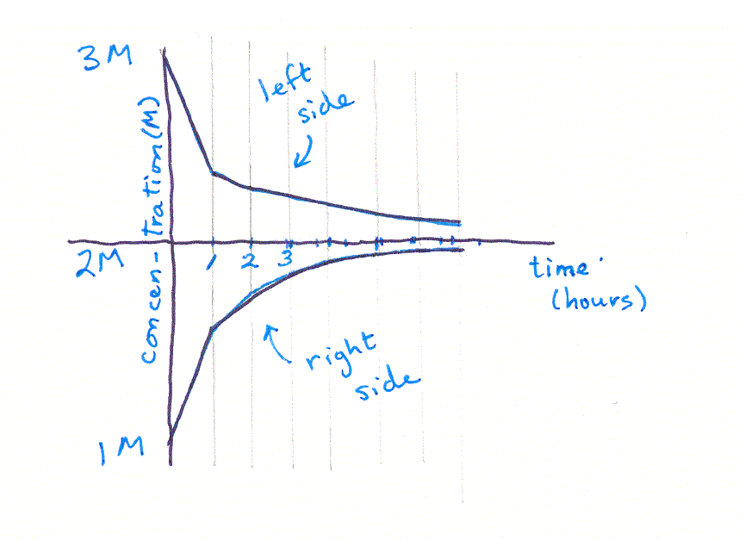
When we use the discrete equation, how fast the particles move still depends on how different the compartments are, but (and this is the important part) we only calculate the concentrations every once in a while, maybe every hour (so Δt = 1 hour) . Then we assume they continue to cross the membrane at that rate, for an entire hour. This gives us a straight line segment (like driving your car in a straight line because you're not adjusting the steering wheel) which is a little steeper than it would be in the continuous version of the graph (like heading into a sharp turn and not readjusting the steering wheel).
At t = 1 hours, we recalculate how many particles are on each side and how fast they will move across the membrane. Likewise at t = 2 hours. And t = 3 hours. And so on.
Notice that this curve looks "segmented" or jerky, especially when its steep. Like the twisty road, when things are changing fast, the discrete equation will not approximate the path well.

Iterating the discrete curve
We compared the shape of the curves given by the two models. Solving the continuous model here is beyond the scope of this module (that would get into a lot of calculus), but we can do the discrete model with a modest amount of algebra.
Let's go back to sugar water, with the following assumptions:
Initial concentration on left = 1 M
Initial concentration on right = 0 M
P = 0.1 cm/sec
A = 1 cm²
We want to know what the final concentrations will be over time , i.e., at time 1 sec, 2 sec, 3 sec, 4 sec....... So lets set up our equation from above we know that :
Δn/Δt = 0.1 cm/sec x 1 cm² x (1M - 0M) = 0.1 moles/sec
So in the first second, approximately 0.1 moles change sides (from the more concentrated to the less concentrated side). That leaves
on the left side: 1 moles - 0.1 moles= 0.9 moles/liter
on the right side: 0 moles + 0.1 moles= 0.1 moles/liter
How about the concentrations at time 2 seconds? We need to readjust our estimate of diffusion rate by plugging in the new concentrations. Everything else stays the same:
Δn/Δt = .1 cm/sec x 1 cm² x (.9M - .1M) = .08 moles/sec
and the new concentrations are 0.82 and 0.18M.
on the left side: 0.9 moles - 0.08 moles= 0.82 moles/liter
on the right side: 0.1 moles + 0.08 moles= 0.18 moles/liter
Continuing on like this,
Δn/Δt at 3 seconds = 0.074 moles/sec, C on left = 0.746 M, C on right = 0.254 M
Δn/Δt t at 4 seconds = 0.049 moles/sec, C on left = 0.697 M, C on right = 0.303 M
Δn/Δt t at 5 seconds = 0.039 moles/sec, C on left = 0.658 M, C on right = 0.342 M
Δn/Δt at 6 seconds = 0.032 moles/sec, C on left = 0.626 M, C on right = 0.374M
This process is called "iteration" -- you iterate, or repeat, the equation over and over, each time substituting in the values calculated in the last iteration. You can see that, if we continued iterating long enough, we would eventually reach a point where the two concentrations were equal -- in other words, an equilibrium. (It would take a long time though, better use a spreadsheet rather than a calculator!) If you graph the two sets of concentrations, you'll see something like this:

