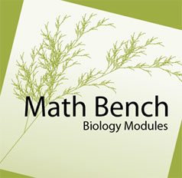
Probability:

BLAST and (Im)probability

URL: http://mathbench.umd.edu/modules/prob-stat_blast/page01.htm

Note: All printer-friendly versions of the modules use an amazing new interactive technique called “cover up the answers”. You know what to do…

Foreshadowing: Combinatorics
This module will make heavy use of the 'Law of Combining', which you probably learned in grade school, but without the fancy name. For example, in grade school you got a problem something like this:
Nancy Drew, girl detective, is heading out to Solve the Case. She has 3 blouses and 4 skirts in her closet (the housekeeper is behind on the laundry). How many different outfits can Nancy make?
You have to agree that Nancy has 12 possible outfits (although her father, famous lawyer Carson Drew, will probably veto the tank-top/miniskirt combination).
You will probably also have noticed that 12 = 3 * 4, which is not a coincidence. There are 3 kinds of tops Nancy could put on, and for each of these, she could choose 4 skirts.
The Law of Combining says:
If you want to count the possible combinations of ONE PICK from set 1 and ONE PICK from set 2, you can just multiply the size of set 1 by the size of set 2.
Or simply,
N_{tot} = N₁ * N₂

After the Drews' housekeeper catches up with the laundry, Nancy has 17 blouses and 32 skirts. How many outfits can she make?
- remember to multiply the number in the first set by the number in the second set.
- the first set consists of 17 blouses...
Answer: 544.

No calculator? Just pull out your trusty slide rule.
No slide rule? Go to Google, type in the equation (i.e., "17*32=") and hit enter!
No browser? Get Firefox! Web designers everywhere will thank you. And you can tab to a new page to make your calculations on Google.

Combining Letters into Words
It is possible to use the Law of Combining even if the two "sets" are actually identical. For example, you might want to know how many two letter words there are in the English language.
To simplify matters, let's assume that ANY combination of two letters is a word, regardless of whether it contains a vowel or not.
In this case, "set 1" contains all the letters in the English alphabet. So does "set 2".
So the number of words is: 676
Think for a minute about these questions:
1. Does it matter what order you pick the letters? YES! The words "ON" and "NO" are different words. So are "AH" and "HA". The multiplying method of combining would count these as separate words. There are other methods of combining sets that DON'T take order into account, but we're not interested in those at the moment.
2. Does it count if you pick the same letter twice? YES! In this system, "OO" is a word. So is "UU" (actually, that's a religion). So is "MM" (almost a candy). Again, the multiplying method would include each of these as words.
A popular children's game involves making new words from a long word or phrase. For example, you could start with BIOLOGY FOR FUN AND PROFIT and make NAP, FAN, BART and BRAT. One way to generate new words is simply to try all possible combinations of letters.

How many 5-letter words could be made?
- Although the phrase contains 22 letters, several are repeated. There are only 14 distinct letters.
Answer: 537,824 (=14*14*14*14*14)

Sometimes hitting the multiplication key so many times gets to be a bit tedious...

How many 12 letter combinations are possible?
- typing 14*14*14*14*14*14*14*14*14*14*14*14 into Google (or a calculator) is boring... there must be an easier way.
- multiplying something by itself 12 times is the same as raising to the 12th power.
- for Google: Use the "^" key to get a power, like this: "14^12="
Answer: 5.67 × 10¹³

This is a good trick to remember: if you are making a string of choices from the same set, then instead of multiplying repeatedly, you can simply use the a power. If we want to make a 12 letter word, and we have 14 letters available to us, we can do this:

14*14*14*14*14*14*14*14*14*14*14*14 = 5.67 × 10¹³

to figure out how many possible words we could make, or we could simply do this:

12^14 = 5.67 × 10¹³

The first way is a little easier to understand -- it almost looks like a 12-"letter" word. But the second way is a lot faster to calculate.

Uh oh, what was that answer again?
The number of 12-letter combinations from the phrase "BIOLOGY FOR FUN AND PROFIT" was 5.67 × 10¹³ . Both Google and your calculator will give you something like that, rather than a civilized number like 56693912432456.
Why? Well, 56693912432453 might be too big to fit on your calculator's display. Or it might not, but you have to admit it's a difficult number to read. Is it billions? Trillions? Quadrillions?
Instead, scientists (and calculators and browsers) use scientific notation:
• 10¹³ is a one with thirteen zeros, or 10,000,000,000,000. Which is 10 trillion, incidentally.
• So 5.67 × 10¹³ is about 57 trillion.
Quick Review:

What is the log of 5.67 × 10¹³ (approximately)?
- Remember that the log tells you how many "spaces" the number takes up.
- The 10¹³ tells you the number takes up 13 spaces.
- 5.67 × 10¹³ is about halfway between 10¹³ and 10¹⁴.
Answer: A little more than 13.5. The actual answer is 13.75.

And you can see, there is a nice relationship between scientific notation and the log scale.
Notice, finally, that 5.67 × 10¹³ does NOT include all the digits of the exact answer. Even though the exact answer is valid in this case, it would be a pain to write it all out, and frankly, whether there are 56693912432453 words or 56693912432459 words or even 56693999999999 words doesn't make much difference. When you're talking about TRILLIONS, it's like the old joke, a million here, a million there, maybe someday you're talking real money.
So in summary, there are 4 ways we could express this number:
- 56693912432453
- about 57 trillion
- 5.67 × 10¹³
- 13.75 on a log scale

What can you say with 4 letters?
Just in case you're not a Nancy Drew fan, Nancy is the girl detective, Bess is the pleasingly plump if clueless girlfriend, and George is the tomboy. That just about sums up most of the plots. Anyway, in some updated universe, Bess writes for a fashion magazine and George runs the Human Genome Project. Where she has just discovered 'the sleuthing gene'. And is being interrogated by Bess.
"So you're telling me that you have an 'alphabet' with just 4 letters? "
"Yup, just A, C, T and G"
" It doesn't seem like you could say anything very interesting with 4 letters. I mean, come on, you'd be repeating yourself constantly!!"
"That's not true. The chances of repeating even a moderately long string of DNA are astronomically low. Even a single 3-letter 'word'..."
"Oh really? They all look the same to me. There's CAT and TAT and TAG and TAA... It's not exactly Shakespeare. I bet there aren't more than about a dozen possibilities."

How many possible 3-letter 'words' can you make with A, C, T, and G?
- Remember the multiply-to-combine rule.

Answer: 4*4*4 = 64 possibilities.

"Wait a minute," interrupts a disgruntled Bess. "I know there are only 20 amino acids, and every 3 bases code for one amino acid, so there can't be 64 possibilities, but only 20."
Patiently George explains that the reason there are 64 three-letter combinations but only 20 amino acids is that each amino acid can be coded in at least 2 ways. Thus, CAT is the same as CAC, as far as the cell's machinery is concerned. They both code for histidine. Nevertheless, they are still distinct combinations of A, C, T, and G.

Ready for some big numbers?
Our story so far: George claims to have found a new, unique sequence of DNA which codes for the sleuthing gene. It is 165 nucleotides long.
Bess has pooh-poohed her friend's claim, stating that all possible 165 nucleotide sequences have already been discovered.

In fact, about how many unique 165-nucleotide sequences are possible?
- Use the combine-by-multiplying rule 165 times ... or use the shortcut involving exponents.
- Get ready for some serious scientific notation.

Answer: 4^165 = 2.19 × 10⁹⁹.
A Google is "one" with a hundred zeros, right? So the answer to the problem above ("2" with 99 zeros) is one-fifth of a google. It is a seriously huge number. If it doesn't boggle your mind, you need to get your mind-boggler checked.
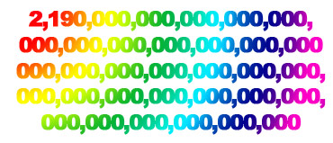
Put another way, there are a fifth of a google of distinct nucleotide sequences that would code for a 55-amino-acid peptide. That's an awful lot of sequences. And it seems pretty unlikely that they've all been discovered already!

How many distinct 55-amino-acid sequences are there?
Recall that there are 64 different 3-letter combinations of nucleotides, but only 20 amino acids. Furthermore, you know that the first codon in the sequence has to be a start codon, and the last one has to be a stop codon.

So, how many distinct amino acid sequences are there?
- How many amino acids in the peptide? 165/3 = 55, minus the start and stop makes 53.
- Apply the combine-by-multiplying rule 53 times... or use the shortcut.

Answer: 20^53 = 9.00 × 10⁶⁸.
So, there are 2.19 × 10⁹⁹ distinct 165-nucleotide sequences, but only 9.00 × 10 ⁶⁸ distinct 53-amino-acid peptides. That's a big difference, and suggests a lot of repetition in DNA.
On average, how many ways can each 53-peptide sequence be coded?
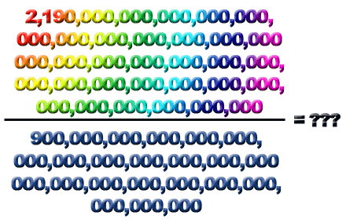
If you don't want to do problems like the above, you will need to know how to divide numbers in scientific notation!

Detour: Multiplying and Dividing Scientifically
Somewhere along the line, you probably learned the "rule of 10" -- to multiply two numbers that are followed by zeros, you need to multiply the numbers (without zeros) then add the total number of zeros, like this:
7000*800 = 7*8 (plus 5 zeros) = 5,600,000
Well, scientific notation works EXACTLY the same:
7 × 10³ * 8 × 10² = 7*8 (plus 5 zeros) = 56 × 10⁵
In shorthand: multiply the numbers, add the zeros.
Division is similar -- divide the numbers, subtract the zeros:
5,600,000 / 7000 ... cancel 3 zeros ...
5600/7 = 800
56 × 10⁵ / 7 × 10³ = 56/7 (with (5-3) zeros) = 8 × 10² .

There are 200 children in an elementary school, and each one brings 3.1 × 10⁶ germs. How many germs is that?
- 200 = 2 * 10².
- 2 × 10² * 3.1 × 10⁶ = ?
- Multiply the numbers, add the zeros.

Answer: 6.2 × 10⁸ , or 620 billion.
...and...

The Health Department estimates that a school contains 9 * 10¹² germs. How many germs is that per child (200 kids in the school)?
- 9 × 10¹² / 2 × 10² = ?
- divide the numbers, subtract the zeros.

Answer: 4.5 × 10¹⁰ , or 45 billion per child.

So, how many codes per peptide?
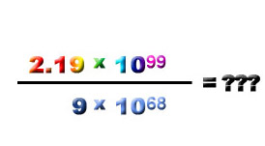

If there are 2.19 × 10⁹⁹ distinct 165-nucleotide sequences, but only 9.00 × 10⁶⁸ distinct 53-amino-acid peptides, how many ways (on average) can each peptide be coded?
- you want codes per peptide, so divide the number of nucleotide sequences by the number of peptides.
- 2.19 × 10⁹⁹ / 9.00 × 10⁶⁸ = ?
- divide the numbers, subtract the zeros.

Answer: 0.22 × 10³¹ , a.k.a. 2.2 × 10³⁰.
Wow! 2.2 × 10³⁰ is 2 million trillion trillion. That's the number of ways (on average) that any given 53-AA protein could be coded. Ten million times more than the number of atoms in a mol. Once again, if your mind isn't boggled, better get it checked out.
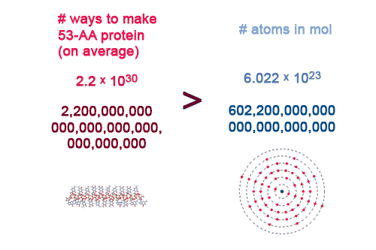

To be or not to be ... in blast
Back to Bess -- who still believes that all the possible 165-nucleotide sequences have already been discovered and cataloged in BLAST. After all, she reasons, the BLAST human genome contains about 5 trillion sequences of that, which does seem like an awful lot.
Recall, however, that we found that 2.19 × 10⁹⁹ 165-nucleotide sequences are theoretically possible. What percentage of the theoretically possible sequences are actually contained in BLAST?

Assume there are 5 trillion 165-AA sequences in BLAST. What percentage of 165-nucleotide sequences is this?
- Convert 5 trillion to scientific notation.
- Find percent by dividing the number existing by the total possible, then multiply by 100.
- 5 × 10⁹ / 2.19 × 10⁹⁹ = ?
- To divide scientific notation -- divide the numbers, subtract the zeros.
- Don't forget to add 2 zeros.

Answer: 2.3 × 10⁻⁸⁸.
In other words, if you wanted to write this as a percentage, you would need more than 80 zeros after the decimal point, like this: 0.00000000000000000000000000000000000000000000000000000000000000000000000000000000000000000023%.

BLAST: Do try this at home!
So, for 165-nucleotide sequences, there are almost 10⁹⁰ theoretical sequences for every actual archived (human genome) sequence. That's an awful lot of theoretical sequences that just aren't used (or at least haven't been found) in the human genome!
Another way of saying the same thing is this:
The chances of typing a RANDOM 165-nucleotide sequence into BLAST and getting a hit is 1 divided by 10 ⁹⁰ , or vanishingly small.

Review
The Law of Combining says:
If you want to count the possible combinations of ONE PICK from set 1 and ONE PICK from set 2, you can just multiply the size of set 1 by the size of set 2.
Or simply,
N_{tot} = N₁ * N₂
If you are picking multiple times from the same set, you can use an exponent:
N_{tot} = (N_{set} ) ^{# picks}
Using the Law of Combining will often get you some very big numbers, which might be better expressed as
- scientific notation, or
- logs
Nucleotides form a 4-letter alphabet and the same Law of Combining applies to them as well.
Amino acids form a 20-letter alphabet. Any amino acid sequence can be coded in MANY possible ways.
Although BLAST contains a huge number of nucleotide sequences, it is tiny compared to the number of POSSIBLE nucleotide sequences.
In order to compare sizes, you need to divide. For scientific notation, this means
"divide the numbers and subtract the zeros".

