
Population Dynamics:

Frank’s Football Fiasco

URL: http://mathbench.umd.edu/modules/cell-processes_meningitis/page01.htm

Note: All printer-friendly versions of the modules use an amazing new interactive technique called “cover up the answers”. You know what to do…

The story...
Frank was a college sophomore. He lived in the dorm, and aside from being a pretty good student, he was an avid sports fan- both watching and playing. He and his roommate Sven often took a study break on Saturdays to play some kind of game. Sven, who came from Sweden, loved to play soccer. Frank played football in high school, but he was pretty much game for any kind of sport.
One sunny Sunday right after lunch, Frank and Sven decided to organize a pickup game of flag football. They got enough guys to agree to play, and it turned out to be a really competitive game. After about ten minutes of play, they all agreed to take a quick water break. Frank reached for his bottle of water, glad that he had been careful to write his name on it with a Sharpie this week. Last week he had chugged down the remains of Sven’s water, pouring a little bit on his head and face to cool down, before he realized his mistake. He was a little grossed out, but fortunately Sven was a pretty healthy guy and didn’t have a cold or the flu.
The next play was a long pass, and several of the players on his team went flying down the field to catch it. Unfortunately Frank was paying so much attention to the trajectory of the ball that he didn’t notice the other guy’s elbow until it connected with his nose. They made Frank lay down so that they could get the bleeding stopped, and then made sure his nose hadn’t been broken. Frank decided he’d better take it easy the rest of the day, so he headed back to his room to lie down. Sven went along just to make sure Frank was OK. After about half an hour, Frank fell asleep.
Sven woke him up at six o’clock so that he wouldn’t miss dinner. Frank went to dinner despite the headache. He realized he’d been clocked pretty hard, so he wasn’t surprised at either the headache or the bruises that were beginning to show on his face. He ate his dinner, then went back to his room, took a couple of aspirin and made it an early night.
At about three o’clock in the morning, Frank woke up feeling worse. He was feeling feverish, which was confirmed when Sven put a hand on his forehead and told him he felt really warm. The medical center didn’t open until seven the next morning, so Frank figured he’d have to wait a few hours before he could see a doctor. When he sat up he noticed that his neck was really stiff.
He thought it might be a good idea to check out the internet to see if he could get some advice on how to treat this until he could get some help at the medical center, so he had Sven bring up WebMD on his laptop. He typed in “headache stiff neck fever” to search for his symptoms. The first hit to come up was “Neck Problems and Injuries”. He hadn’t really considered that he might have hurt his neck in the collision, but that was certainly a possibility, so they clicked on the link. It said that you could get an acute neck injury from falling or sports accidents, so Frank lay back down, thinking maybe this was all much more serious than he had thought, and that maybe he should call an ambulance.
Of course, it was likely that if it was a neck injury at all, he probably had just sprained or strained something since it took so long to develop, so he stopped panicking. Sven kept reading the article, and on page two of that entry it gave other possible causes of the headache and stiff neck. They quickly ruled out arthritis- Frank was only 19 years old and arthritis doesn’t have a sudden onset like this. The next choice was meningitis, but Frank had gotten the meningococcal vaccine before he came to campus. Another choice was the flu, but his headache had came on much more suddenly than the flu usually does, and nobody on their floor was sick. Convinced it was just a response to the collision, they waited a few hours and headed for the medical center.
By the time Frank got to the medical center, he started to notice a splotchy rash forming all over his body. He was starting to feel dizzy, nauseous, and the lights were starting to bother his eyes. He pulled his jacket over his head until it was his turn to be seen by the doctor. After telling the doctor the list of symptoms, and explaining the really nasty bruise on his face from the collision and nosebleed, the doctor asked if he had had the meningococcal vaccine. When he said that he had, the doctor asked him if he had close contact with anybody from another country. He pointed out that his roommate and best friend came from Sweden.
The doctor immediately prescribed penicillin and got Frank admitted to the hospital for treatment of meningococcal meningitis. Frank was pretty confused as to how he could get meningitis when he’d had the vaccine, but while the paramedics were getting Frank prepared for transfer to the stretcher, the doctor explained that there are several "serogroups" of the bacteria that cause meningococcal meningitis, and that not all of them are covered by the vaccine. In fact, a form that is common in Sweden, serogroup B, is not covered by any currently available vaccine.

Biological interlude

Why isn't Sven sick?
- He has never come in contact with the meningococcal bacteria: WRONG, Sven has come into contact with the bacteria. There's another reason.
- Meningitis is like Chicken Pox -- Sven had it when he was little, and now he is immune: WRONG, Sven has never had meningitis before
- Sven really is sick, he just hasn't told anyone: WRONG, meningitis is a rapid and deadly disease. It wouldn't be possible for Sven to hide it.
- Sven carries the meningitis bacteria, but it doesn't affect him: TRUE, Sven is an asymptomatic carrier. In fact, many Scandinavians are not affected by this bacteria. Sven carries the bacteria in his nose and throat.

How did the organism get from Sven to Frank?
- Sven gave Frank a bloody nose, and the bacteria was transferred directly into the bloodstream. WRONG, Sven doesn't carry the bacteria in his blood, and he couldn't transfer it to Frank that way. (Also, he wasn't the one that gave Frank the bloody nose).
- Sven and Frank have been breathing the same air because they live in the same dorm room. WRONG, meningitis is not transferred through the air.
- Frank drank from Sven's water bottle. TRUE, because the bacteria is in Sven's nose and throat, it can be transferred on shared cups or utensils.
- Sven often leaves dirty dishes laying around. WRONG -- although it is true that the bacteria can be transferred to utensils and cups, it does not live for long outside of the body, so coming in contact with an old dirty dish will not transfer the bacteria.

Let's assume that Frank got the bacteria into his throat, and that it happened last week. If Serogroup B doesn't usually cause an invasive infection, then why does Frank get sick?
- Frank has a gene which causes him to be receptive to Serogroup B? WRONG, this has nothing to do with genetics
- Frank was playing football all afternoon, so his immune system was depressed. WRONG, regular exercise boosts your immunity to infection.
- Frank got a nosebleed. Well, yes, you're getting close...
- Frank's nosebleed offered the bacteria a way into his bloodstream. TRUE, this is exactly right. The nose and throat are not terribly nutrient-rich places, but the bloodstream is cozy and warm and contains lots of sugar and other nutrients. In fact, the bloodstream contains all of the essential nutrients needed for bacterial growth. (That's why many human pathogens are cultured on blood agar)

Is it a good idea for college students to get immunized for meningitis?
- No, they get all the immunizations they need by the age of 5. WRONG, meningitis is not generally covered with childhood vaccines.
- No, because most people get over meningitis. DEFINITELY WRONG, meningitis is a very rapid and often deadly disease. Even people who recover can suffer from brain damage and other problems.
- No, because college students are no more likely than anyone else to get meningitis. WRONG, college students are more likely than most people to come down with meningitis.
- Yes, because college students do many careless things, so they need lots of vaccinations. This may be true, but it is not what causes an upsurge in meningitis rates in college.
- Yes, because college students encounter many people from other countries. TRUE, college students come in contact with people from many parts of the world, who may assymptomatically carry forms of the bacteria that most Americans would be susceptible to.

How many meningococci can kill you?
So we've established that meningitis is caused by Neisseria meningitidis, which are currently running around like crazy in Frank's bloodstream. Because this disease has been researched extensively, doctors can even tell you how many bacterial cells you need to have in your blood before you're likely to die.
LD50 = 500 cells/mL blood
"LD" means "lethal dose", and 50 means that 50% of the time, someone exposed to this dose will die. So basically, if your blood has 500 of the bacterial intruders per mL, you have about even chances of dying from meningitis. Above 500 per mL and you're even more likely to die.
We can scale up from here to figure out how many bacterial cells Frank's body can handle before it's likely to kill him.
about 5 liters of blood per adult
about 5000 mL
5000mL * 500 cells/mL = 2,500,000 cells
So now we know that by the time that Frank has about 2.5 million meningococci in his body, he's likely to be toast.
Frank vaguely remembers from first year biology that bacteria can grow exponentially, but in his current less-than-stellar state, he doesn't quite remember how that works. Let's refresh his memory...

Build the basic growth equation
As you know, bacteria multiply by dividing, so to speak. A single bacterium grows and then divides into 2. Those two "daughter" cells eventually divide in 2. And so on.
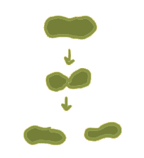
The equation for exponential growth should be familiar to you. Starting with one cell dividing in half, the resulting numbers would look like this:
# in gen₀ --> 1
# in gen₁ --> 1*2
# in gen₂ --> 1*2*2
# in gen₃ --> 1*2*2*2
# in gen₄ --> 1*2*2*2*2
Instead of writing "# in gen 4", it is more usual to write N(4). Likewise, for the general equation we write N(t). So, given the formulas above, which of the following is the correct equation for exponential growth starting from a single cell?
N(t) = t * 2^{t} | N(t) = 1 * 2t | N(t) = 1 * 2^{t} | N(t) = 1 * t²
no -- otherwise  N(3) = 3 * 2*2*2 = 24 | no -- otherwise  N(3) = 1 * 2*3 = 6 | yes -- for example,  N(3) = 1 * 2*2*2 = 8 | no -- otherwise  N(3) = 1 * 3*3 = 9
With a few more changes, we can make this look more official.
- Most importantly, Frank may not have been so lucky as to start with one single, solitary invading meningococcus. Maybe, despite his killer immune system, he had 2, or even 3. So, instead of the initial population being 1, let's call it N₀, pronounced "n sub zero", meaning "the number of cells in generation 0". (This is also really important when we're talking about lab populations that may have started with much larger numbers).
- Less importantly, I removed the multiplication sign - it's still there, just invisible.
Our final equation looks like this:
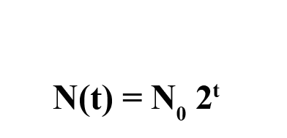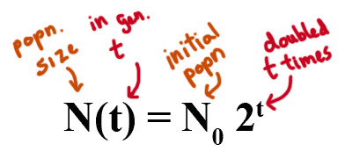

Draw exponential growth
The online version of this module contains an interactive applet which allows you to draw an exponential growth curve. To find this applet go to: http://mathbench.umd.edu/modules/cell-processes_meningitis/page05.htm | 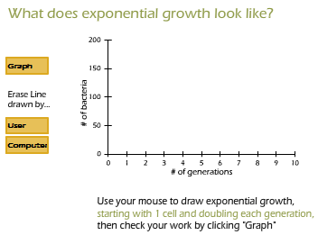
So, on regular graph paper, exponential growth looks like a curve heading up (or accelerating). When a few meningococci double, that only gives us a few more. But when thousands of meningococci double, we get thousands more. When a million double, we get a million more.
Pretty soon we've got a real infection going on.
(Note for people who are way ahead: In a few screens we'll find out that the graph-on-regular-paper doesn't work very well when talking about bacteria, and we'll fix that problem. But we're not there yet.)

How long has poor Frank got?
An amazing thing about meningitis is that the initial infection can be caused by a SINGLE CELL. Despite the thousands that are probably holed up in Frank's nose and throat, despite the spectacular nosebleed, despite everything, Frank's immune system has done and great job and let just one tiny cell survive.
So, how many doublings (or generations) does the cell have to go through to get to 2.5 million? (Remember, 2.5 million is the LD50 scaled up for 5 liters of blood).
Here's a likely but vague answer: probably not as many as you think. Let's try some numbers. You can play along at home using a calculator, or just click the buttons to see the answer:
10 generations: 1024
20 generations: 1,048,576
30 generations: 1,073,741,824
The magic number is 2.5 million, and by 20 generations, Frank's already got over 1 million. Double that and you're already past the 2 million mark. So, basically, Frank's got a little over 21 generations... however long that is...

All we need now is data
We know that bacterial populations grows exponentially (N_{t} = N₀ 2^{t}), and we know how many are likely to kill him (2.5 million), and we even know how many generations it will take to get to that number (about 21 generations) but what we don't know is... how fast are the generations? Or, put another way, what is the doubling time?
If the doubling time is a week, or a year, it would take a really long time to get to 2.5 million meningococci, and Frank could take some medicine go home feeling pretty confident. That would still be exponential growth, but it would be very slow. Like molasses.
But if the doubling time is in the seconds or minutes, then Frank is in real trouble.
So, how fast do meningococci populations double? Let's order up some data, stat!

Looking at data
Look to the right below... wow, that was fast. Now we have some typical data on meningococcal bacteria grown in the lab. Maybe we can use this to figure out how long it takes for meningococci to double their population -- and from there we can tell how long "21 generations" is. But it's hard to interpret just numbers, so let's try putting it on a graph.
The online version of this module contains an interactive applet which allows you to plot the growth of a bacterial population on linear graph paper. To find this applet go to: http://mathbench.umd.edu/modules/cell-processes_meningitis/page08.htm | 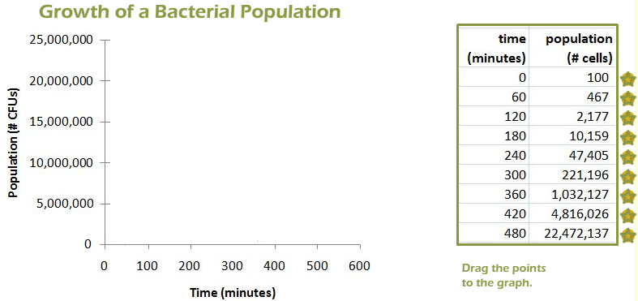
Hmm, that is one ugly graph. All the numbers are either way at the bottom or way at the top. I can hardly make out anything.
It would be nice if we could spread the numbers out a little more... and in fact we can. We need to use graph paper with a "log" scale on the y axis, instead of a regular scale. Since logs tell you the magnitude of a number, they do a better job of spreading out a wide range of values. Let's try that now:
The online version of this module contains an interactive applet which allows you to plot the growth of a bacterial population on semi-log paper. To find this applet go to: http://mathbench.umd.edu/modules/cell-processes_meningitis/page08.htm
OK, now we have a graph that looks reasonable. This kind of graph is called "log-transformed."
What happens is a series of numbers that are evenly spaced on a linear scale get spaced differently on a log scale: specifically, on a log scale, the largest numbers get squished together, while the smallest numbers get stretched apart.

Log transform straightens out exponential growth
What we did on the graph is called log transformation, which is a very powerful tool in biology, even if it cannot transform 18-wheelers or pickups trucks into sentient beings.
What you do when you log-transform data is change the scale of the data. Normal everyday data is usually expressed on a graph with a linear scale. Linear means that each tickmark on the axis increases the number by the same amount -- for example, the tickmarks might stand for 0, 5, 10, 15, etc.
However, our bacterial population is not increasing by the same amount in each timestep. Starting with 1 cell, in the first timestep we add 1 more, in the second timestep we add 2 more, in the third timestep we add 4 more, and so on. The graph does not look like a straight line.
When you transform data, you are putting it on a log scale, which is also called a multiplicative scale. The tickmarks on a multiplicative scale represent numbers that differ by the same FACTOR, or multiplier. And in fact our bacterial populations also differ by the same factor at each timestep -- they double, or increase by a factor of 2.
So when you use a log scale, populations separated by the same factor will line up in a straight line. The slope of that line will depend on how big the multiplying factor is, which we'll talk about in a few screens. But the crucial point is:
When logtransformed:

ANY population that grows or shrinks by a constant factor will appear as a straight line (pointing up or down)

ANY population that is constant will appear as a flat line.

Do ALL curves get "straightened" by taking the log?
The online version of this module contains an interactive applet which allows you to log transform different curves. To find this applet go to: http://mathbench.umd.edu/modules/cell-processes_meningitis/page10.htm | 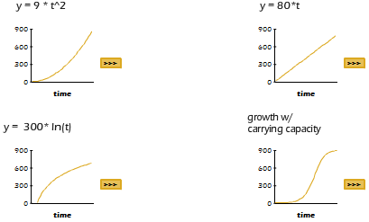
So, although log transformation is powerful, it is not ALL-powerful. The only curves above that get straightened are the ones generated by functions that include "some number to the power of the x variable". Why is that? Recall:
ANY population that grows or shrinks by a constant factor will appear as a straight line when log-transformed.
And that's what doubling does -- it multiplies the population by a constant factor (2, that is) over a constant period of time. But other mathematical functions, such as the ones above, involve some sort of change in which the factor of change is NOT constant. Let's take the parabola, for example: y = x²
x | 1 | 2 | 3 | 4 | 5 | 6
y | 1 | 4 | 9 | 16 | 25 | 36
factor |  | 4 | 2.25 | 1.78 | 1.56 | 1.44
The factor by which y is increasing starts at 4, then drops to 2.25, then 1.78, and so on. Although we might think that a parabola grows "pretty fast", it is in fact "slow" compared to exponential growth that starts with the same factor.
As a general guideline:
- if growth factors are increasing, then growth is proceeding faster than exponential, and that part of the log-transformed curve will have a relatively steep slope.
- if growth factors are decreasing, then growth is proceeding slower than exponential, and that part of the log-transformed curve will have a relatively gentle slope.
- Only constant growth factors (exponential growth) leads to a straight-line when the graph is log-transformed.

Phases of bacterial growth
Now that you can recognize exponential growth easily, let's explore our data a bit on the log-transformed graph. In the applet below, you can move the slider around the graph to find the 4 "phases" of bacterial growth in a lab culture.
The online version of this module contains an interactive applet which allows you to observe various phases of bacterial growth. To find this applet go to: http://mathbench.umd.edu/modules/cell-processes_meningitis/page11.htm | 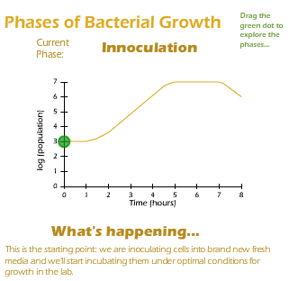
Which is the only phase that involves growth of bacterial population? LOG -- the straight line part of the graph, pointing up

A test for exponential growth
Actually, it’s very useful that only exponential growth gets straightened out by log transformation. Now we have a quick-and-easy test to find out if a population is undergoing exponential growth. Namely
- Plot the population on log paper.
- Decide if the trajectory forms a straight line.
That's pretty much it!! A straight line on graph paper means exponential growth (if the line goes up) or exponential shrinkage / death (if the line goes down). If the line is straight but completely flat, it means no change, just like on a regular graph.
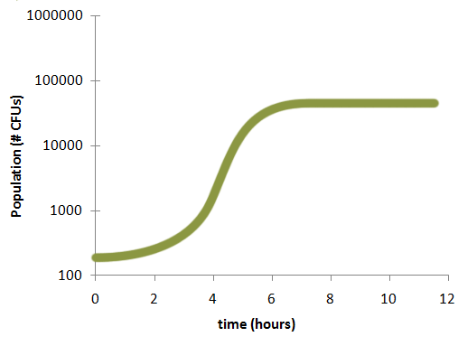
When was the population growing exponentially? Exponential, the straight line part of the graph, pointing up -- from about hours 4 to 5
When was the growth slowing down? Starting around 6 hours
When was the population constant? Anytime after 7 hours, and also in the first hour

And the answer is...
Pretty clever so far... but the whole reason we got this data in the first place was to figure out how fast the bacteria can double, and so far we still haven't managed to do that.
If we look at the actual data again, we can see that we weren't lucky enough to ever observe the actual number doubling, so that won't help.
Look at the graph again and follow the directions to find the actual doubling time.
The online version of this module contains an interactive applet which allows you to practice how to find the doubling time. To find this applet go to: http://mathbench.umd.edu/modules/cell-processes_meningitis/page13.htm | 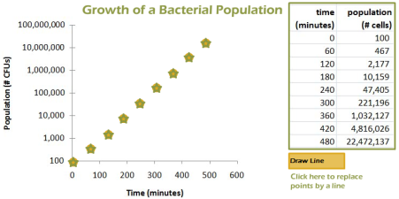
Hooray! Now we know! The doubling time was about 27 minutes.

To recap, 21 generations gets us to a deadly dose of bacteria.

And each generation lasts 27 minutes.

So Frank should be dead in .... 567 minutes, or about 10 hours.
Dum - dum - DUM - DUMMMMM....

No way its growing that fast!
According to the lab data, Frank should be dead in about 10 hours.There's just one problem -- he's not. Well, clearly our data is not making believable predictions. After all, Frank was infected at the time of the nosebleed (5pm), and at 9 the next morning, when the health center opened, he was still alive enough to look like an angsty vampire. That's 16 hours, or 32 generations, or a grand total of about 4 billion meningococci, if we were to believe what the lab data told us.
Luckily for Frank, our lab-based prediction must have been a little too fast. But why?
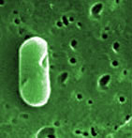
Imagine a single bacterial cell. You might think a cell that is not actively dividing is sitting around, twiddling its non-opposable thumbs or knitting or something. However, this is not actually true. For a while (anywhere from 20 minutes to a few days) the cell spends its time gathering nutrients and synthesizing extra cellular structures. Once that is done, it can divide into two. Any given strain of bacteria requires, on average, a certain amount of time to gather nutrients and organize itself to divide.
However, the time required depends quite a lot on the amount of nutrients available, as well as the temperature and other factors. meningococci desperately need a two nutrients: sugar and iron. Well, sugar is easy to get in the blood stream -- it's just floating around, waiting to be taken up by the body's cell. But not iron. Iron is packaged away inside the red blood cells or complexed with iron-binding proteins. Therefore, the meningococci can't get to this essential trace element, making iron limiting in the bloodstream, but not in the lab culture. This is the first reason for the slower growth in Frank's body.
The second reason is that Frank's immune system is attacking the meningococci continuously. As you might imagine, ferocious attacks put a bit of a damper on mundane activities like eating and synthesizing proteins, not to mention the fact that meningococci might be killed off almost as fast as they divide.
So perhaps a better way to estimate doubling time would be like this:

The average meningitis victim survives about 36 hours, and

We know that 21 generations of meningococci are needed

So each generation must last 36 / 21 hours = 1.7 hours, or 100 minutes.
Bottom Line? Instead of 27 minutes (in a lab population), meningococci are doubling in about 100 minutes (in the body), due to 2 factors discussed above:
- nutrient sequestration (iron locked away), and
- mortality and slowed growth from immune system attack.
Luckily for Frank!

Some more practice
There are fast and exact ways to solve these kinds of problems (if you remember your advanced algebra), and there are slower and less exact ways (if you don't). Either way is fine here, although the hints will only be for the non-advanced-algebra route.

What if exactly 3 meningococci surrived the initial onslaught of Frank's immune system? In that case, how long would it be before the critical level of 2.5 million organisms was reached?
- Remember the equation: N0 * 2^t
- In this case, the initial population size (N0) is 3.
- If you don't remember advanced algebra, you just have to start guessing.
- We know it should be less than 21 generations.
- Let's try 15 generations: 3*2^15 = approx 98,000. Not enough.
- 3*2^19 = about 1.6 million, but 3*2^20 = about 3.1 million.

Answer: between 19 and 20 generations
The guess-and-try method is fine, if a little slow. However, if you understand how doubling works, you can make some intelligent guesses and speed up your answers. For example, if 2.5 million cells require 21 generations, what would 1.25 million cells require? 20 generations -- only 1 generation less.
With that in mind, try the next problem.

What if Frank was a 10 year old girl with 2.5 liters of blood (as opposed to Frank-the-Flag-Footballer's 5 liters)? In that case, how many generations would it take to get to the lethal level?
- Remember that the LD50 was based on cells per mL of blood. So, with 1/2 of the blood, the lethal level would be 1/2 of the number of cells.
- If we only need 1/2 the cells, that's one less doubling. So instead of 21 generations, we need...

Answer: 20 generations
One last problem, just to make sure you've got it.

What if Frank had just given blood, losing about half a liter, plus his weakened immune system let 5 meningococci though? Poor Frank!
- Frank is down to about 4.5 liters of blood
- Remember, the LD50 is 500 cells per mL
- 4.5 liters = 4500 mLs, so the LD50 is about 2.25 million cells
- So, 5*2^?? = at least 2.25 million -- try a few numbers...

Answer: 19 generations gives 2.6 million cells

In search of ... the exact doubling time
So far, we've been guesstimating doubling time from a graph of population over time. But there is a problem...
Guesstimating a parameter from a graph is not really approved scientific procedure. It would be hard to imagine publishing a report in the Journal of the American Medical Association that started out "we looked at the graph, squinted a little, and decided that the doubing time was 23 minutes...".
It can be possible to calculate the doubling time from a table of data, that only if the table happens to include an exactly doubled population. If the table does NOT contain a doubled population entry, then you're in trouble. In other words, we can figure out the exact doubling time for nice timeseries below, but not for messy one:
time | nice | messy
10:00 am | 10 million | 10 million
10:20 am | 20 million | 15 million
Clearly, nice doubled in 20 minutes. And at first glance, it appears that messy got "halfway" to doubling, so doubling time should be 40 minutes. Let's see if that's true -- if the population keeps growing at the same rate, will it double in 40 minutes?
time | messy
10:00 | 10 million
 | ... multiply by 1.5 to get
10:20 | 15 million
 | ... multiply by 1.5 to get
10:40 | 22.5 million
Oops, we got to 22.5, not 20 million. Granted, this is a small difference, but it's still not the right answer. Like the old joke goes, a million here, a million there, pretty soon you're talking about a real epidemic. What we need is a foolproof way to determine exactly what the doubling time is.

Finding doubling time with messy numbers
Recall that we started out with an equation:

N_{t} = N₀ 2^{t}
Remember the exponential part of this equation is that we raise 2 to the power of the number of generations, t. Another way of saying this is that, for every generation, we multiply the original population by 2.
Let's say I told you that N₀ was 10 million and N_{t} was 80 million one hour later. Luckily for you, these are nice neat numbers. You would probably think to yourself, "well, the population doubled three times, from 10 to 20 million, from 20 to 40 million, and from 40 to 80 million. Since three doublings took 1 hour, that means each doubling took 20 minutes."
Another somewhat fancier way of getting the same answer would be to substitute the information that you know (N_{t} and N₀) into the equation above, and solve for the information that you don't know (number of generations, t). Here's how that would look:

What is the doubling time? (10 million -> 80 million in 1 hour)
Hint | Explanation
sub in the known info | 80 million = 10 million * 2^{t}
divide out the initial population | 8 = 2^{t}
use common sense! | t must be 3
3 doublings in 60 minutes means... | 60min/3doublings = 20min/doubling,  so the doubling time is 20 min

Let's try the same basic procedure with messier numbers. Let's say the population increased from 10 to 70 million in one hour.

What is the doubling time? (10 million -> 70 million in 1 hour)
Hint | Explanation
sub in the known info | 70 million = 10 million * 2^{t}
divide out the initial population | 7 = 2^{t}
use common sense...? | t must be ... hmmm... a little less than 3...

We have not solved our problem yet, and what's in the way is that 2 is raised to some power in order to get 7 -- but we don't have a way to calculate what that power is. In other words, the exponent is the trouble. We need a way to get the "exponential" out of "exponential growth" so we can deal with the math. But how?

Logs = Exponent-busters
In a word: when you have a problem with exponents, try logs. The great thing about logs is that they take everything down a notch. Multiplication gets busted down to addition. Exponents get busted down to multiplication.
If you're already comfortable with manipulating log expressions, just skip to the next page. Otherwise, here is a quick reminder and attempt to rationalize that exponent-busting magic.

What is a log?
What logs tell us is the magnitude of a number -- how much space the number takes up on paper.

If the log is 3, then the original number is a '1' followed by three zeros.

If the log is 4, then the original number is a '1' followed by four zeros.

If the log is between 3 and 4, then the original number is something bigger than '1' followed by three more digits.

How do logs turn multiplication into addition?
So far so good. Let's take it another step. When we multiply 2 normal numbers, we're basically ADDING their magnitudes. Therefore
100 * 1000 = 100,000
The number 100 has 2 zeros, 1000 has 3 zeros, and their product has 2+3=5 zeros. By not-coincidence, the MAGNITUDE of 100 is 2, the magnitude of 1000 is 3, and the magnitude of 100,000 is 5.
The moral of the story so far: logs allow us to deal with numbers as magnitude, so it turns multiplication into addition.

How do logs turn exponents into multiplication?
As you know, using an exponent is a short-hand way of indicating repeated multiplication.

2⁵ = 2 * 2 * 2 * 2 * 2
So logs turn (repeated) multiplication into (repeated) addition

2⁵ = log(2) + log(2) + log(2) + log(2) + log(2)
Another way of saying "repeated addition" is "multiplication"

2⁵ = 5* log(2)
So the whole moral of the story is: logs knock exponents down to multiplication, and they knock multiplication down to addition.
Bottom line: logs are a biologist's best friend...!

Let's bust some exponents
logs knock exponents down to multiplication, and
logs knock multiplication down to addition.
So let's try using these rules where we ran into trouble before. Recall that we got as far as finding the log in our equation -- now we can bust right past it...

What is the doubling time? (10 million -> 70 million in 1 hour)
Hint | Explanation
sub in the known info | 70 million = 10 million * 2^{t}
divide out the initial population | 7 = 2^{t}
Bust that exponent | log(7) = t * log(2)
This looks complicated, but really all you need is a calculator | 0.84 = t * 0.30
Now some rearranging... | t = 0.84 / 0.30 = 2.8
So there were 2.8 generations in 60 minutes, so.... | 60 / 2.8 = 21.4 minutes each!!

Maybe I should have said, logs plus a calculator are a biologist's best friend....

Let's bust some exponents
So, give that a try on your own.

Let's say we think that Frank's bloodstream was infected by a single meningicoccal cell at 3 pm, and by the next day at 3pm, he had a thriving population of about 10,000 meningicocci loose in his blood. Assuming exponential growth, how fast was the population doubling?
- Start with the basic equation for exponential growth: Nt = N0 * 2t, where t means the number of generations.
- Remember that you already know both population sizes, so plug them in
- You should get to an equation that has only 1 variable, but that variable is an exponent. Time to bust an exponent!
- Once you've got an equation with only one variable and a few logs, use your calculator to get the value of the logs.
- Once you know t (how many generations or doublings there were), you should be able to use common sense to figure out how long each generation was.

Answers: #generations = log(10000)/log(2) = 13.3, length of generations = 24*60 / 13.3 = 108 minutes

Extended problem #1: Exponential growth ends (with a whimper)
Here's a second set of data on meningococcal growth rates. Your instructions are 1) to determine the exponential growth rate of the bacteria, and 2) to determine when growth stops being exponential.
time | popn
0 min | 4.3 * 10⁶
20 min | 9.7 * 10⁶
40 min | 22 * 10⁶
60 min | 48 * 10⁶
80 min | 97 * 10⁶
100 min | 116 * 10⁶
120 min | 118 * 10⁶
140 min | 67 * 10⁶
Just look at the data first... what can you see with your bare eyes, so to speak?
About doubling time: The population doubles a little more than once in the first 20 minutes, so doubling time is probably between 15 and 20.
About the general shape of the population trajectory: In general the population rises, levels out (around 100 minutes), and then falls (around 120 minutes).
About when growth begins to slow down: Each 20 minutes, the population more than doubles, until 80 minutes, when it just barely doubles. So maybe at 80 minutes it is no longer exponential?
The online version of this module contains an interactive applet which allows you plot bacterial growth and calculate doubling time. To find this applet go to: http://mathbench.umd.edu/modules/cell-processes_meningitis/page16.htm | 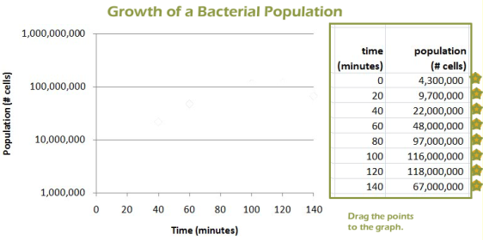
So...
About doubling time: The population doubles a little more than once in the first 20 minutes, so doubling time is probably between 15 and 20.
About when growth begins to slow down: Each 20 minutes, the population more than doubles, until 80 minutes, when it just barely doubles. So maybe at 80 minutes it is no longer exponential?

Extended Problem #2: How long DOES poor Frank have?
Based on lab tests, Frank has 80 meningococci per mL of blood at 9am. Assuming he got infected by a single cell at 5pm, then
- What is the doubling rate of the meningococci cells?
- How long does Frank have before he reaches the LD50?

Doubling rate?
- 80 / mL * 5000 mLs = 400,000 cells
- 1*2^19 = about 524,000, so just under 19 doublings
- 5pm to 9am = 16 hours = 960 min
- 960 minutes / 19 doublings = about 51 minutes/doubling

Answer: about 51 minutes

How long does he have?
- 400K --> 800K --> 1.6 million --> 3.2 million
- Less than 3 doublings
- 3*51 = 153 minutes

Answer: about 2.5 hours

