# 

# Measurement:

# The Size of Things

**URL:** <http://mathbench.umd.edu/modules-au/measurement_sizes/page01.htm>

## Learning Outcomes

After completing this module you should be able to:

* Use appropriate units of length for different measurement contexts (milli-, micro- and nano- worlds)
* Convert units of length

## Tall (and small) fish tales

How big is a fish? Ask a fisherman and he will tell you it was as big as his outstretched arms. Ask his friend and he will hold up his forefinger and thumb and say “it was this small”…… But what is the truth and how can you be sure of the actual size of the fish?

From your primary schooling and everyday experience you have an intuitive sense of measurement and this is used to standardize measurement for everybody, no more tall stories about the size of a fish! We can put a physical size to the fish that everybody can understand.

From your everyday life, you have an intuitive sense of what a centimetre, a metre and a kilometre look like.

Now that you’re studying biology, you need to develop the same intuitive sense of what a millimetre, a micrometre, and a nanometre look like.

The hard part is that, while we can see a centimetre, things that are on the order of millimetres are kind of small, things on the order of micrometres can rarely be seen directly, and nanometres – you might as well forget seeing them without a really good microscope.

Nevertheless, we’re going to try to divide up the biological world into these scales and do what we can. Before we start, it will be helpful to have a ruler (or anything else that can easily measure millimetres) and a calculator on hand.

## Metric conversions: step to the right, step to the left

First, the basics. One metre (which is oddly enough just about the same size as a metre stick) can be divided into 1000 parts called millimetres.

So, if I want to convert a measurement in millimetres to metres, I can do it by moving the decimal point 3 places to the left:

277.0 mm −> 0.277 m

Likewise, if I want to convert a measurement in metres to millimetres, I can do it by moving the decimal point 3 places to the right:

0.341 m −> 341 mm

If you don't have any decimal places to move to the right, then you need to add zeros:

345 m −> 345000 mm

34.5 m −> 34500 mm

A lot of people remember the part about moving the decimal point over by 3, but don’t remember whether it goes to the left or the right. There’s an easy solution for this: make sure your answer makes sense! Millimetres are pretty small. It’s going to take MORE millimetres than metres to make the same measurement.

A few big units = Lots of small units

If you convert the length of your finger (70 millimetres) into 70,000 metres, stop and think a moment. 70,000 metres is pretty ridiculous.

If you divide a millimetre into 1000 pieces, you get a micrometre, abbreviated µm, or um (being easier to type on a standard keyboard).

And if you divide a um into 1000 pieces, you get a nanometre, or nm.

So altogether now:

* 1 metre is 1000 millimetres
* 1 millimetre is 1000 micrometres (or microns, or µm, or um)
* 1 micrometre is 1000 nanometres (or nm)

## 3 Worlds: Milli, Micro, Nano

We can roughly divide most phenomena of biological interest into 3 scales: the milliworld (1 metre to 1 millimetre), the microworld (1 millimetre to 1 micron), and the nanoworld (1 micron to 1 nanometre).

To get a first, rough intuition about these scales, it helps to figure out what belongs where. You already know plenty of biological phenomena that belong in the milliworld -- things like cats, mice, eyeballs, fruit flies... Notice that that's quite a range. The smaller worlds are harder to visualise because you don't see them every day.

So what’s in the microworld? Starting with the biggest stuff and going down…

* protists and single-celled animals
* cells of plants or animals (eukaryotes)
* bacteria (prokaryotes)

And what’s in the nanoworld? Again, starting with the biggest stuff …

* parts of cells (like mitochondria, chloroplasts, and so on) are right on the border between the micro and nano worlds
* visible light wavelength
* viruses
* cell membranes
* large molecules (like proteins, carbohydrates, hemoglobin, etc.)
* DNA double helix
* small organic molecules (like simple sugars)

I am not trying to say that there is some kind of magical division between the microworld and the nanoworld, or that the rules of physics suddenly change or anything like that. The reason that I’m talking about microworld and nanoworld is just to give you a point of reference, to help you figure out which units will be most convenient, and which biological structures have similar sizes.

## Focus on the Microworld

Notice how micrometres have a lot of names? You can call them microns (this will sound like you know what you are talking about, in case you have a crush on a biologist), or you can call them micrometres (accent on the “o”), or "um", or use the Greek letter, µm.

Microns got so many names because in a lot of ways, they have received the most attention from biologists. From the invention of the optical microscope in the 1600s all the way until the mid-1900s, biologists have been able to see into the microworld, but not farther. So, naturally they came up with a lot of terms for micrometres.

The microworld has been very important in biology, and you’ll spend much of your first year in biology getting familiar with what happens there. And we actually can do a little bit of hands-on measurement of the microworld.

What we’ll do is measure a stack of thin things in order to figure out how many microns each individual thin thing is. Got it? Good.

For example, take your ruler and measure 1millimetre worth of pages in your textbook.

How does this relate to microns? Recall that 1 mm is 1000 um. So, for example, if there were 2 pages in a millimetre, you would divide 1000 mm by 2 to figure out that each page was 500 microns thick.

I got 14 pages to the millimetre in my textbook, which made my pages 71 um each (approximately). Just for fun I also tried it with:

* a stack of business cards (220 um each)
* the Brisbane white pages (61 um each)
* toilet paper (100 um each)

So in general I think we can conclude that most paper is around 100 um thick. Squarely in the microworld.

## Practice measuring in the Microworld

The microworld, as we defined it, goes from 1 to 1000 microns. We know that paper is about 100 microns. What about stuff smaller than that?

Below is a scale drawing. Your job is to eyeball the sizes of the different things in this world using the drag-and-drop microscope viewing area.

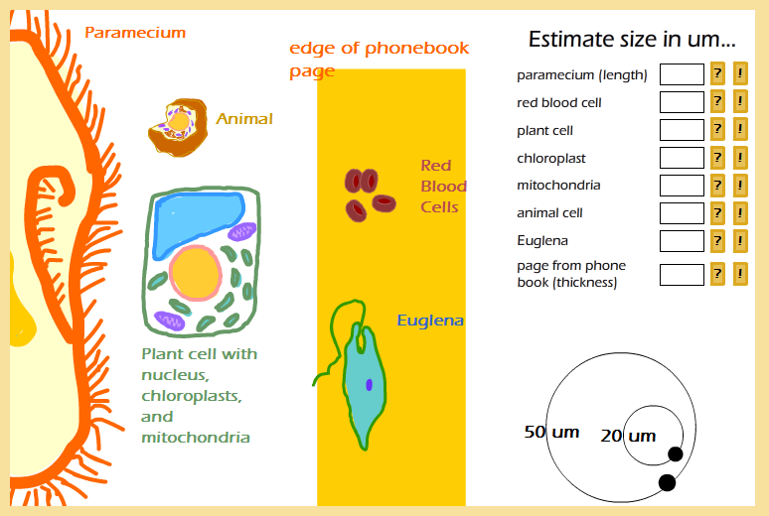

Answers: 50, 7, 50, 8, 10, 20, 40, 100

So once again, the microworld is basically the world of cell-sized things, from giants like multicellular animals (dust mites), to big single-celled organisms (like protists, euglena and paramecium), down to plant and animal cells (generally in the 5 to 30 um range). Some of the largest structures inside cells, like the nucleus, mitochondria, and chloroplasts, are just at the bottom of the microworld.

## Next stop … the Nanoworld

Cells and bacteria belong in the microworld; organelles like the nucleus, mitochondrion, and chloroplast just barely belong to the microworld. You can think of the cell as a microworld city, and the organelles as microworld-sized factories within that city. The machinery of the cell organelles, however, belongs to the nanoworld. That includes the DNA that contains instructions, and the enzymes that do the actual work, the food molecules like glucose to be metabolised, the membranes that keep the cell interior safe, and even the viruses that infect the cell. All of these are nano-sized….

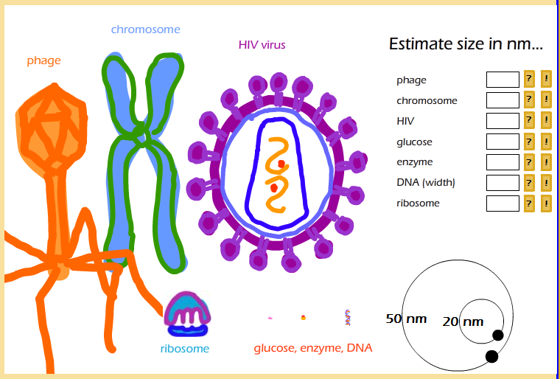

Answers: 200, 100, 80, 1, 2, 2, 10

So at the top of the nanoworld would be the smallest bacterium, measuring in at 1000 nm. Visible light is somewhere in the middle – between 340 and 780 nanometres. Below that are most viruses, including the T4 (which looks like a lunar lander, and helps protect us against *E. coli* gone bad) and one on everyone’s least favorite list, the HIV virus. At 100 nm, chromosomes are about the size of small viruses, which makes sense considering that viruses are basically just DNA in a protective coat. Smaller than that are the enzymes, membranes, DNA strand, and at the very bottom, a glucose molecule, coming in very close to 1 nanometre.

## End of the line… the Picoworld

Of course there are things smaller than glucose. These include water molecules, carbon dioxide, hydrogen atoms and chemical bonds. Most of these things are in fact in the picoworld – you guessed it, 1 picometre = 1/1000 nanometres. However, if you want to go there, you’ll have to find a different tour guide.

But, bottom line, don’t expect to find molecules with less than about 20 atoms in the nanoworld.

And really REALLY don’t expect to find the building blocks of atoms -- protons, neutrons, or electrons -- there.

However, I strongly recommend taking a look at the following sites: Cells Alive (<http://www.cellsalive.com/howbig.htm>) and “the scale of universe” (http:// htwins.net/scale2 ).

They are very nice animations which allow you to zoom in and out on some things in the micro- and nano- worlds and give you visual examples of the scale and the size of things!

## Summary

I hope you’ve enjoyed the tours of nanoworld and microworld. In case you’d like a short list of things to remember, here are some suggestions:

In the microworld

* 900 um - fly's eye
* 100 um - paper
* 7 um - red blood cell (on the small side for a plant/animal cell)
* 1-10 um - bacteria, mitochondria, and chloroplasts

And in the nanoworld:

* 100 nm - viruses
* 10 nm - cell membrane
* 2 nm - DNA double helix
* 1 nm - glucose molecule

## Learning Outcomes

After completing this module you now should be able to:

* Use appropriate units of length for different measurement contexts (milli-, micro- and nano- worlds)
* Convert units of length