
Cell Processes:

Osmosis

URL:
http://mathbench.umd.edu/modules-au/cell-processes_osmosis/page01.htm

Learning Outcomes
After completing this module you should be able to:

- Determine that osmolarity of a solution
- Use the two compartment model to determine which way water will flow through a selectively permeable membrane, and the rate of flow of water

Osmosis is a special kind of diffusion
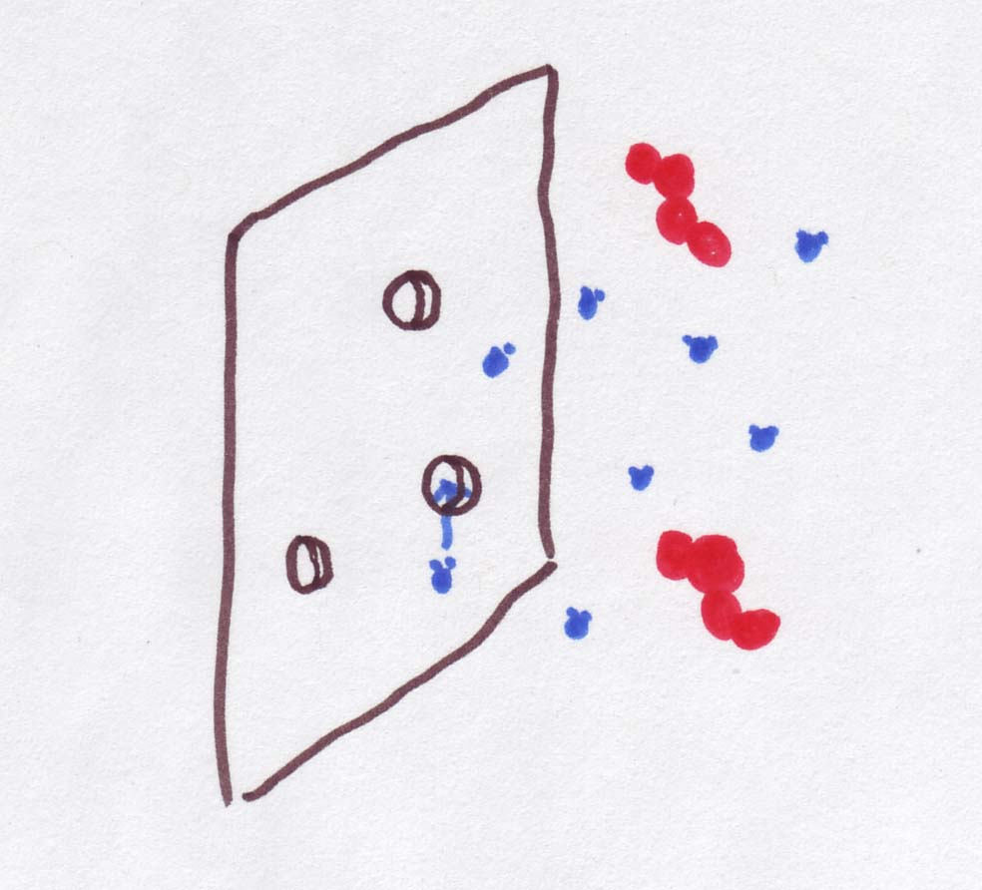
First we told you that diffusion through a membrane was just a special case of diffusion -- we got you to assume that there were only two compartments of interest (left and right), which simplified the maths a lot.
Now, we're going to tell you that osmosis is a special case of diffusion through the membrane. And it's the membrane that makes it special. Recall that membranes vary in terms of their permeability. Some might be like the proverbial brick wall, while others might be 'as leaky as a sieve'. Imagine a membrane with gaps* just big enough to let water through, but too small to let anything else across.
How is this a special case of diffusion through a membrane? Basically, what happens is that water can diffuse through the membrane, but nothing else in the water -- salt, sugar, or other solute – can.
Instead of general permeability of the membrane, what we care about now is permeability to water, or P_{water} .
Continuous form
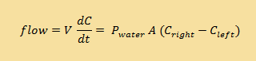
Discrete form | 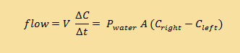

*more properly, permeability of the membrane has to do with selective gateways and polarity and so on, but imagining gaps in the membrane will work too.

Putting the "Os" into "Osmolarity"
We need to make one other change. So far we've used the molarity (moles of solute per litre) of solutions, like sugar water, as our way of measuring concentration. In truth, the measure of concentration that we need is not molarity, but osmolarity. Osmolarity is defined by osmoles of solute per litre (kind of like moles, but with an OS on the front). The abbreviation, which we'll use a lot, is OsM.
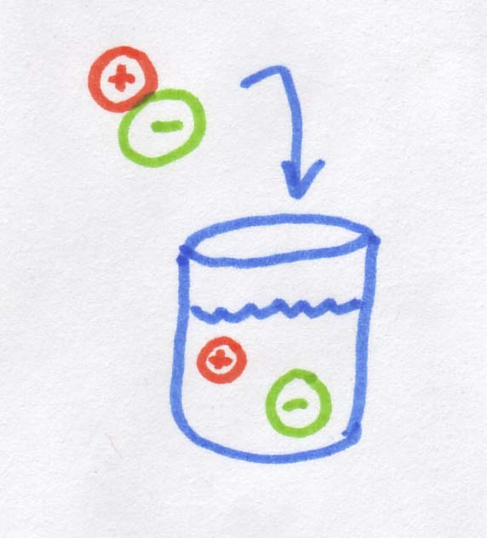
So what is an osmole? As you may know, when you dissolve salt in water, it dissociates into Na⁺ and Cl⁻, in other words, into two pieces. If 1 mole of molecules dissolves into two "pieces" it creates 2 osmoles. If we started with 1 mole of MgCl₂, which dissolves into 3 "pieces", we would get 3 osmoles. Sugar is an organic rather than ionic compound, so it does not dissociate, and 1 mole of sugar dissolves into 1 osmole. So when you are working out osmolarity the first thing you will need to determine is whether or not the salt in question dissociates into smaller ions.
When we're talking about diffusion across a membrane (including osmosis), it doesn't actually matter that salt ions are smaller than sugar molecules, or that their molecular weight is less, or even that the ions are charged while the sugar molecules are electrically neutral. The only thing that actually matters is how many "pieces" the salt dissociates into. For example for a salt "molecule*" that dissociates into two ions, when you dissolve it into water, you will get TWO ions rather than one, and this is what matters for diffusion. Essentially the salt molecule provides twice as many "bits" of dissolved stuff as the sugar molecule, so the osmolarity is also doubled.

If I dissolve 2 moles of table salt (NaCl) in 1 litre of water, what osmolarity is produced?
- One molecule of salt makes 2 "bits" when dissolved
- 2 moles of salt will make 4 moles of "bits"

Answer: 4 moles of "bits" / 1L of water = 4 OsM

If I dissolve 4 moles of MgCl₂ in 2 L of water what will the osmolarity be?
- MgCl₂ dissolves into Mg²⁺ + 2Cl⁻ or 3 bits
- osmolarity is "bits" / litre

Answer: 4 moles MgCl₂ = 12 moles of "bits" 12 moles / 2L = 6 OsM

*Yes, I know that salt is an ionic compound and comes in the form of crystalline lattice. However, it is easier to think in terms of a salt "molecule"

Calculating osmolarity

If you know molarity:

What is the osmolarity of a 2.6 M solution of table salt (NaCl)?
- Salt dissolves into 2 "bits".
- Read the section above again!

Answer: 2.6 M * 2 = 5.2 OsM
If you need to figure out the osmolarity of a solution and you're given the molar concentration, its pretty simple, just multiply the molarity by however many "pieces" the solute dissociates into.

If you know the amount of solute:
What if you just know the amount of a solute that was added? For example: what is the approximate osmolarity of the sugar in a can of Red Bull? According to the can which just happens to be sitting next to me, there are 27 g of sugar in 250 mL. The sugar in Red Bull is a mixture of glucose and sucrose (a disaccharide made up of one molecule of glucose and one molecule of fructose bonded together). The molecular weight of sucrose is 342. For simplicity, however we will assume here that all the sugar is in the form of glucose.
First, grams to moles: 27g * 1 mole/180g = 0.15 moles
Finally, we know that sugar does not break apart, so 1 M = 1 OsM.
Now that everything is in the right units, we just need to divide moles by litres to get the osmolarity:
0.15 moles / 0.25 litres = 0.60 OsM.

What is the osmolarity of a glass of skim milk? (13g of lactose in 236 mL)
- Lactose is a kind of sugar and has a molecular weight of 342g per mole.
- 13g lactose * 1 mole/342g = 0.038 moles. Lactose does not dissolve into smaller "pieces".

Answer: 0.038 moles / 0.236 litres = 0.16 OsM
So the osmolarity of Red Bull is 0.60 OsM, whereas the normal osmolarity of plasma is 0.288 OsM. Think about that next time you have a Red Bull for breakfast!

It can take many solutes to make osmolarity
On the last screen, we calculated the osmolarity of the sugar in Red Bull to be 0.60 OsM. That is not, however, the same thing as the osmolarity of Red Bull. The reason is that sugar is not the only thing dissolved in that can. For example, there are also 35mg of salt. To calculate the total osmolarity, we also need to take the salt into account (as well as a bunch of other minor players like color and flavor molecules, but we'll stick with the salt for now).
In order to figure out how many moles of salt we have, we need to know the molecular weight. One mole of sodium weighs 23g, and one mole of chlorine weighs 35.4g. When the sodium and chlorine are combined in a single molecule, one mole of salt weighs 23 + 35.4 = 58.4g.
So, converting from mg to moles: 35.4 mg * 1 g / 1000 mg * 1 mole / 58.4g = 0.00060 moles
And we know that salt dissociates into one sodium ion and one chlorine ion (Na⁺ and Cl⁻), making TWO moles of ions. Or,
0.00060 undissolved moles --> 0.0012 moles of dissolved ions
And, remembering that there are 0.25L the osmolarity associated with the salt is:
0.0012 osmoles / 0.25 liters = 0.0048 OsM
To get the total osmolarity of the Red Bull, we add up the two osmolarities associated with each ingredient:
total osmolarity = 0.60 OsM + 0.0048 OsM = 0.6048 OsM.
Obviously we could keep going down the ingredient list, but probably you've got the idea by now.

What is the osmolarity of seawater given the following:
Solute | g / L | molecular weight
Cl⁻ | 19 | 35
Na⁺ | 10.5 | 23
Mg | 1.3 | 24
S | 0.8 | 32

- To convert grams to moles, multiply grams by 1 / molecular weight.
- Add all the molarity from first hint.

Answer: 19 * 1/35 + 10.5 * 1/23 + 1.3 *1/24 + .8 * 1/32
= 0.54 + 0.46 + 0.054 + 0.025
= 1.08 OsM = 1080 mOsM

Which way will water flow?
Why does all this matter? Water has a tendency to move across a membrane from a lower osmolarity to a higher osmolarity. In other words, from the dilute side to the concentrated side. The outcome is that the dilute side loses water and becomes more concentrated, and the concentrated side gains water to become more dilute, so the two sides become more similar.
In the figure osmolarity is 3 times higher on the right, but the red molecules are trapped over there. Instead, the water can move, so it goes TOWARDS the high-osmolarity side. That makes the left side more concentrated and the right side less concentrated | 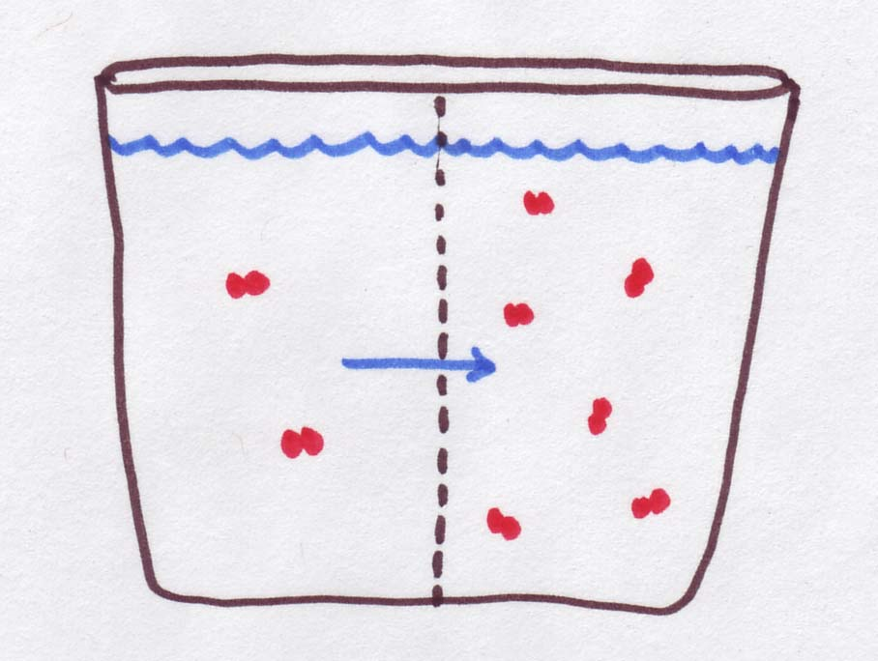
In the figure below, there are 3 solutions (0.2M, 0.5M, and 0.7M) separated by membranes. Your job is to figure out which direction(s) water is moving:
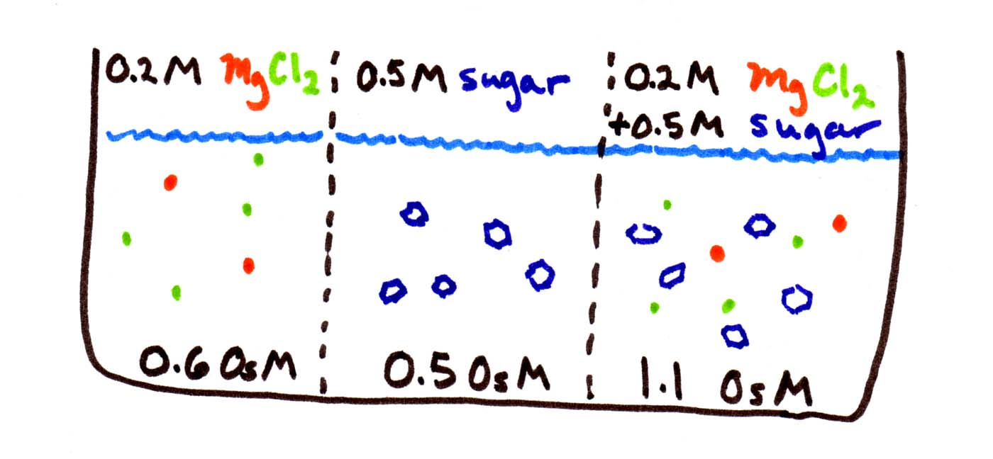
The first thing to be careful of is to calculate the osmolarities before you start. Since MgCl₂ dissociates into 3 pieces, its osmolarity is triple, i.e., 0.6 OsM. Sugar does not dissociate, so it stays at 0.5 OsM. The third solution contains both sets of solutes, so its osmolarity is 0.5+0.6 = 1.1 OsM.
Then remember that water goes from low to high osmolarity, from weak to concentrated solutions. You can think of it as water "trying" to equalise the concentrations. So water flows from the middle compartment to either side, since both have higher osmolarity.

… and how fast?
We determined which way water flows, but shouldn't it go faster to the right (toward the very concentrated solution) than to the left (a solution that is barely different in concentration)? In fact this is true, and it is directly reflected in the equation for the 2-compartment model:
Continuous form
Discrete form

We don't know either the permeability (P_{water}) or the area of the membrane (A). But this doesn't really matter if we just want to know how the rates of flow compare. We do know how the concentration differences compare (C_{right} - C_{left} ). Between the first and second compartments, the difference in osmolarity is only 0.1 OsM. Between the second and third compartments, the difference in osmolarity is 0.6 OsM. So water should flow 6 times faster to the right than to the left.
Of course this state of affairs only lasts for a split second. As soon as water starts to flow, the concentration differences change, and the relative rates of flow change until equilibrium is reached. If you are using the continuous equation, the adjustments will be made immediately. If you are using the discrete version, the adjustment will only be made after Δt time has passed.

What else can the equations tell us?
Continuous form
Discrete form
Here are a few last questions on interpreting the equations:

What will the rate of water flow be if permeability is zero?
- Permeability is P_{water}.
- Zero times anything is zero.

Answer: No matter how high the difference in osmolarity, no osmosis will occur if the permeability is 0. For example, osmosis will not work through a brick wall

When will the rate of water flow be the highest?
- the product of three quantities is maximized when each quantity is maximized

Answer: Assuming that area (A) is constant, you need the permeability (P) to be as high as possible. You also need the difference in osmolarity (C_{right} – C_{left}) to be as high as possible – for example, one side pure water with OsM = 0 and the other side with as high osmolarity as possible.

What happens if the osmolarity of the two solutions is the same?
- If the osmolarities are the same, what about the concentrations?

Answer: If the two sides have the same concentrations, then (C_{right} – C_{left}) = 0 and NO net osmosis will take place, no matter how large or leaky your membrane is.

None of these was really rocket science. The point is that the equation for rate of water flow is simply a formalisation of what our intuition tells us should happen. The equation puts intuition into mathematical language!

Where does it all end?
So, a quick recap. We can figure out which way water is flowing. Also, using the iteration technique at the end of the section on diffusion through a membrane, we can figure out how much water is flowing at each time step (Δ t).
However, there is still one more property of the system that we can figure out -- what happens at the end of that slower and slower process -- in other words, what are the equilibrium concentrations, and how much water is on either side of the membrane. We can do this without endlessly pushing buttons on a calculator.
Let's use sugar as an example. Say we started with 0.2 moles of sugar in 1 litre of water on one side, and 0.8 moles of sugar in 1 litre of water on the other side and the two compartments are the same size. The water is free to move back and forth across the membrane, but the sugar's not going anywhere, and no extra sugar or water can move in or out of the 2-compartment system. So at the end of the day,
•there will still be 0.2 moles of sugar on one side and 0.8 on the other side,
•and there will still be 2 litres of water,
•and the concentrations on either side will be equal,
•BUT the water will not be equally distributed.

How can you find the final water levels using intuition?
- The final water level on the 0.8 mole side must be 4 times higher than on the 0.2 mole side.
- The total water level has to add up to 2 litres

Answer: 1.6 L+ 0.4 L fulfills these conditions

How can you find the final water levels using formal equations?
- the final molarities must be equal, so
0.2/W₁ = 0.8/W₂ , or
0.2 W₂ = 0.8 W₁ ,or
W₂ = 4 W₁
- The total amount of water is 2 L so W₁ + W₂ = 2

Answer: Substitute 4 W₁ for W₂, so W₁ + 4 W₁ = 2
5 W₁ = 2
W₁ = 0.4 L
W₂ = 2 - 0.4 = 1.6 L

Drink your water
Let’s apply what we have learnt above to the situation where a person drinks 1.5 litres of water.
The osmolarity of bodily fluids is approximately 0.3 OsM (or 300 mOsM). The total fluid volume of a normal person is about 45 litres, of which 30 litres is inside cells (Intracellular volume) and 15 litres is outside the cells (Extracellular volume which includes plasma). We can use these figures to determine the total number of solutes present in each compartment.
Osmolarity (osmoles/L H₂O) x volume (Litres) = total solutes (osmoles)
Below is a table of the osmolarities associated with the intracellular and extracellular compartments

before taking the drink:
Before drinking | Volume | osmolarity | Total solutes in compartment
Total body | 45 litres | 0.3 OsM | 0.3 x 45 = 13.5 osmoles
intracellular | 30 litres | 0.3 OsM | 0.3 x 30 = 9.0 osmoles
extracellular | 15 litres | 0.3 OsM | 0.3 x 15 = 4.5 osmoles
After drinking 1.5 litre of water, the water will be absorbed by the gastrointestinal tract and will enter the plasma and extracellular fluid and will equilibrate with the intracellular compartment. As the solutes that are present inside the cell cannot leave the cell, equilibration will only involve the movement or diffusion of water (Osmosis).
Let’s look at what happens to the whole body first:
After drinking | Total solutes | volume | osmolarity
Total body | 13.5 osmoles | 46.5 litres | 13.5 ÷ 46.5 = 0.29
The new osmolarity is 0.29 and not 0.3OsM. Water will move to equilibrate the intra- and extra- cellular compartments to this NEW osmolarity. To determine the movement of water we work back from the osmolarity.
After drinking | Total solutes | volume | osmolarity
intracellular | 9.0 osmoles | 9.0 ÷ 0.29 = 31.0 litres | 0.29
extracellular | 4.5 osmoles | 4.5 ÷ 0.29 = 15.5 litres | 0.29
So we can see that because the solutes do not move out of the cells the 1.5 litres of water will distribute so that 1 litre stays in the extracellular space and 0.5 litre diffuses across the cell membrane to the intracelullar compartment.

Sharks and alligators and goldfish, oh my!
So what, if anything, does all of this tell us about life-as-we-know-it? Here is one small example.
Below is a table of osmolarities associated with environments and organisms:
seawater: 1 OsM | freshwater: 0.001 OsM
shark: 1.075 OsM | goldfish: 0.293 OsM
 | alligator: 0.278 OsM
 | mammal: 0.330 OsM
So a shark is a little "saltier" than its environment, and a freshwater fish is a lot saltier (inside) than the water around it. Why?
Sharks do not generally "drink". Instead they get freshwater from the seawater around them. Because their insides are a little saltier than the water around them, freshwater flows INTO their cells from their surroundings. The opposite of what would happen to you or me, who would get pickled if we spent too long in the ocean.
On the other hand, mammals are a lot saltier than their environment. But when you drink water, your body fluids become more diluted, so water flows INTO your cells. That's why everyone wants you to drink 8-10 glasses a day of water. And by the same token, if you put a shark into freshwater, the results would NOT be pretty. (The difference in OsM between shark and freshwater is 1.074, vs. 0.292 for goldfish and freshwater.)

Summary
Osmosis is a special case of diffusion in which only water moves across a membrane from dilute side (higher water concentration) to concentrated side (lower water concentration).
For osmosis, the measure of concentration changes from molarity to osmolarity. Osmolarity is defined by osmoles of solute per litre of solution e.g. 1 mol/L solution of KCl has molarity (M) of 1, but its osmolarity (OsM) is 2 because KCl creates 2 osmoles by dissociating into K⁺ and Cl⁻ in water. However, a 1M solution of glucose has an osmolarity of 1 OsM because glucose is not an ionic compound and it does not dissociate into smaller pieces in the presence of water.
The osmolarity of a solution is given by adding the osmoles of all the solutes present in the solution.
During osmosis, the rate of flow of water across the membrane depends on number of factors including permeability of membrane to water, the area of membrane and the concentration difference between the two sides. These factors are summed up in the equation:
Flow = P_{water} * A * ΔC (ΔC = C_{right} – C_{left})
So, if ΔC is doubled flow of water would double and so on.
Eventually equilibrium is reached when concentrations on both sides are the same however, under equilibrium conditions, the amount of water on both sides will not be equal.

Learning Outcomes
You should now be able to:
- Determine the osmolarity of a solution.
- Determine which way water will flow through a selectively permeable membrane, and find the rate of flow of water using a two-compartment model.

