# 

# Cell Processes:

# Nernst Potential

**URL:** <http://mathbench.umd.edu/modules-au/cell-processes_nernst-potential/page01.htm>

**Learning Outcomes**

After completing this module you should be able to:

* Predict how ions will move across a membrane according to their permeability and the electrochemical gradient (concentration gradient plus voltage gradient).
* Calculate the equilibrium membrane potential for each ion using the Nernst equation.
* Use the Goldman equation to predict the membrane potential during an action potential.

## Getting through membranes

Water is a small, polar molecule that can get through the cell membrane pretty easily due to the presence of water channels (aquaporins) which are always open and act like a tube connecting one side of the membrane to the other. Other larger or charged molecules find it harder to cross the cell membrane, but they are not completely blocked.

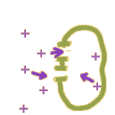In fact, there are two major ways that an ion like Na+ can make it through the membrane:

1. **Through a channel**: Membrane channels can open and close like gates. Once a channel is open, ions are free to move in both directions -- but the **NET movement of ions will be down a gradient**. (More on that later.)
2. 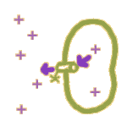**By a pump**: Membranes also contain tiny ATP-driven protein pumps. When these pumps operate, the energy stored in ATP is used to move ions in ONE direction only -- whichever direction the pump mechanism works. This **allows ions to be pushed around AGAINST a gradient**.

## Going with the flow

For most of this module, we'll focus more on channels than on pumps. It's not that pumps aren't important -- in fact, as we'll discuss later, they "set the stage" for everything that's going to happen. Once the stage is set, channels become the interesting part of the system.

An open channel allows conditions inside and outside of the cell to affect each other. And there are two major differences between the inside and the outside:

1. The concentrations of ions are different inside vs. outside the cell. We'll be creative and call this "C" for concentration: in fact, we have a **CONCENTRATION GRADIENT which can power diffusion**. Furthermore, **each ion has ITS OWN concentration gradient**. In other words, K+ ions inside the cell only "care" about how many K+ there are on the outside -- they don't give a fig about Na+ or Cl- or any other anions (A-).
2. As positive (+) ions move through the cell membrane, they can't take negative (-) ions with them, and this results in a slight charge imbalance, inside vs. outside the cell. We'll call this a **VOLTAGE GRADIENT**, or just V. Charged particles "want" to move down a voltage gradient, just like dissolved particles "want" to move down a concentration gradient.

Since ions are both charged and dissolved particles, they have two different gradients to worry about, a chemical gradient and an electrical (voltage) gradient!

Why do I say "two different gradients"? Because the concentration gradient and the voltage gradient don't necessarily have the same effect on the particle -- in fact, **these two gradients are often OPPOSED to each other**.

If a ball is on two opposed gradients, it will come to rest in the middle, right?

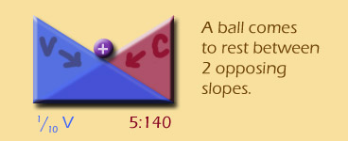

Well, if ions are being affected by two opposing gradients, they will also come to an equilibrium position. Once that equilibrium is found, **the ions can still move back and forth, but the NET movement will be zero -- the definition of an equilibrium**.

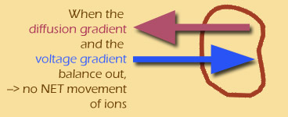

(Throughout this module, I'll use electric blue to show the voltage gradient, and plum red for the diffusion gradient.)

## Permeability is Key!

So there are two opposing gradients affecting membranes: one for concentration, and one for voltage. But, and this is a big BUT:

**The gradients only have an effect IF ions can move through the membrane.** If you put a brick wall in place of the membrane, you could have all sorts of differences in concentration and voltage, but those differences won't have any effect in the real world. A membrane with no open channels is actually a lot like a brick wall.

|  |  |
| --- | --- |
| **Closed channels:** | **Open channels:** |
| closed channels | open channels |

 We'll see how this plays out in the equations soon...

## Meet the neighbourhood

So what's inside (and outside) a typical cell? These are approximate numbers only. We're talking about any cell in your body at the moment, whether it’s in your fingertip, femur, or islet of Langerhans:

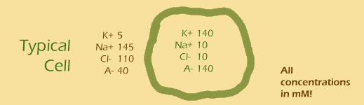

 Let's try adding up the charges on the inside and outside (and remember that Cl**-** and other unspecified anions (A**-)** have negative charges, so these numbers get subtracted!):

Outside: 5 + 145 - 110 - 40 = 0

Inside: 140 + 10 - 10 - 140 = 0

Hmm, the inside and the outside of the cell both have total charge of 0. That's probably a good thing, since you wouldn't really want your cells to be charged.

**charge inside cell = charge outside cell = 0 !!**

However, it does raise a question: if the charge on both sides is zero, why should there be a voltage gradient??? **The key is that the membrane is only permeable to SOME of the ions (usually positively charged ones).** Namely, for most cells most of the time, channels are open for **potassium (K+)** but closed for other ions. (Actually by "open", we mean that individual channels pop open randomly for a few milliseconds at a time,.)

As I said earlier, when K+ leaves the cell by itself, it creates a small imbalance in charge. But this imbalance is SOOOOO small that we couldn't measure it in a useful way. If I wanted to include it on the diagram above, I would need to say something like

**[K+] inside = 139.9999999999mM**

**[K+] outside = 5.0000000001mM**

Amazingly, this slight difference in concentrations is enough to cause a pretty significant voltage gradient. You can measure this electrical potential difference by placing electrodes inside and outside of the cell. When we do this there is a small electrical potential difference with the inside of the cell being negative?

## Getting groovy with gradients

Another thing to get out of the way before we get too far along, is what we mean by a positive or negative electrical potential difference.

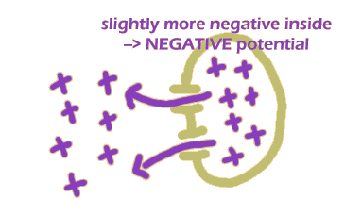The way these things are generally done is to consider the OUTSIDE of the cell to be sort of "neutral" (a ground, if that helps). So if the inside is more positive than the outside, then the voltage potential difference is positive, and **if the inside is more negative, then the voltage potential difference is negative**.

This means that **as K+ leaves the cell, it makes the inside slightly more negative than the outside, and hence there will be a negative potential difference, which will tend to pull the K+ back in**. The concentration difference for K+ will also mean that K+ will continue to leak to the outside of the cell.

Got it? Understanding which way the potential difference goes will help a lot in the next section, so re-read if you need to!

## Some real numbers

Before we get into the psychedelic equations, let's do some simpler maths with ions and channels.

|  |
| --- |
| A typical cell volume is about 10-10 litres, and the concentration of K+ ions is 140mM (millimoles per litre). So, about how many K+ ions are in a typical cell?  * millimoles to moles : 140 millimoles = 0.14 moles) * moles of K+ : (0.14 moles/litre) x ( 10-10 litres / cell) = 1.4 x 10-11 moles/cell * particles per mole: there are about 6.02 x 1023 particles in a mole * so ... : (1.4 x 10-11 moles/cell) x (6.02 x 1023 ions/mole) = ...  Answer: 8.4*1012 K+ ions per cell, or about 8 trillion |

Eight trillion -- let's see, about 1000 times the population of the earth...

Now let's see how many of those 8 trillion ions could be leaving the cell at any given time:

|  |
| --- |
| A typical cell has 10,000 K+ channels, and each channel can let 100,000 ions through per second that it is open. However, the typical channel is only open for 1 millisecond out of every second. So, how many K+ can leave in one second?  * ions per channel opening: 100,000 x 1/1000 = 100 every time a channel opens * ... if each channel opens once a second ... : 10,000 channels x 100 each ions per opening = 1 million  Answer: 1 million ions per second |

A million per second -- if ions were people, that would be the population of Adelaide every second -- sounds like a stampede to me!

|  |
| --- |
| What PERCENTAGE of the cell’s K+ ions can typically leave in 1 second?  * The proportion of K+ ions that typically leave in 1 second is 1 million out of 8.4 trillion. * ... using scientific notation... : 1x 106 / 8.4 x 1012. * ... to divide, subtract the exponents... : 1/8.4 x 10-6 = 0.119 x 10-6 = 1.19 x 10-7 to 3 significant figures. * To convert to a percentage multiply by 100 (100 = 102): 1.19 x 10-7 x 102 = 1.19 x 10-5 % = 0.0000119%.  Answer: 0.0000119% |

**So on the one hand, ions are rushing out at the pace of a million a second, on the other hand, that's only about one ten-thousandths of a percent of the number of ions present! This is a very tiny percentage!! And the movement of that tiny percentage is what causes the tenth-of-a-volt membrane potential.**

Here's another way to think about it: water can gush over a dam at a rate of hundreds or thousands of litres a minute, yet the level of the water above and below the dam doesn't change perceptibly -- because there are millions of litres of water involved. And, despite the fact that the flow is only a small percentage of the total water, it can still do a significant amount of work as it falls.

Finally, let's imagine for a moment that all of the K+ ions could continue to leak out of the cell at the rate of 1 million per second.

|  |
| --- |
| How long would it take to completely empty the cell of K+ ions at this rate?  * how many seconds?: 8.4 trillion ions / 1 million ions per second = 8.4 x 1012 ions / 106 ions per second = 8.4 x 106 seconds. * How long is that? 8.4 x 106 seconds x (1 hour/3600 seconds) = 2330 hours (to 3 significant figures). * In days? Weeks? 97 days or 14 weeks  Answer: 2330 hours |

**This last calculation is a fantasy, because in fact the cell will not continue to empty out at the same rate.** Remember the two opposing gradients? **As diffusion moves ions out of the cell, a voltage gradient builds up which pushes them back in. Eventually the two forces even out and ... voila, equilibrium.**

## The Goldman Equation

**Our story so far:** The sodium-potassium pump is building up a high concentration of potassium inside your cells, and the cell membranes contain potassium channels which are continually opening and closing, allowing up to a million potassium ions back out every second. BUT, we know that as potassium leaves, the charge also builds up on the outside of the cell, which ... stops them from leaving. Eventually there is a balance, or steady state, and what we want to know is:

WHERE DOES THAT STEADY STATE HAPPEN?

Another way of saying this is:

WHAT IS THE VOLTAGE DIFFERENCE THAT BALANCES DIFFUSION?

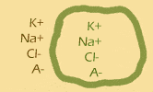Before I show you the actual equation, let's think about what SHOULD affect the equilibrium voltage difference, or equilibrium potential:

* 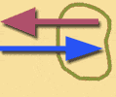**lots of ions**: there are many different ions inside and outside your cells (usually we talk about K+, Na+, Cl-, and then lump the rest together as anonymous anions, or A-). Each of these ions can (under certain circumstances) affect the diffusion-voltage equilibrium. And they are all operating at the same time, so **we should expect to see terms for each in the equation**.
* **the ratio of concentrations:** if I have 1000 times more K+ in the cell compared to outside, that's a very powerful gradient, and it will take a large voltage difference to counteract it, right? Whereas if K+ in the cell is only slightly higher than outside, it won't take much voltage at all. **So, I should expect to see the ratio of concentrations in my equation.**
* 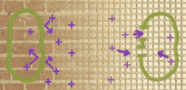**the permeability**: remember the brick wall and the screen? If there is no permeability to a given ion, then that ion won't affect the balance. On the other hand, permeability is not an "on or off" kind of thing. Membranes can be slightly permeable, or moderately permeable, or super permeable ... in other words, we should expect to see a variable for permeability in the equation. Even more than that, we know that each ion has its own permeability variable, so **we should expect to see lots of ion-specific permeability variables in the equation**.

So to summarise, **we need the concentrations of all of the relevant ions, both inside and outside the cell, somehow including their permeabilities, and involving a ratio (or fraction) of inside to outside**. (This reminds me of a cartoon where a student says he's sure he can write his English paper by morning, since the dictionary contains all the words he needs, and he just needs to put them in the right order...)

And now for the right order... (don't worry, I'll show you how to derive a simpler version of this equation in a few screens, for now let's just take it as a gift)

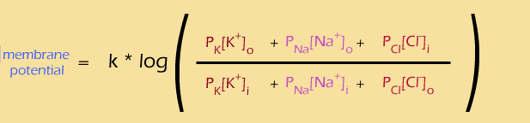

so let's see, we have

* the **membrane potential** (in electric blue) ... check
* the corresponding **concentration gradients** (in various shades of red) ...check
* **lots of ions** (K+, Na+, Cl**-**) ... check
* **permeabilities of each ion** (the P variables) ... check
* **ratio of outside to inside concentrations** (the fraction) ... check

Looking good so far. There are also a few features we didn't anticipate, such as the constant (k) and the log. We'll talk about them on the next page...

## Playing with the Goldman Equation



Let's look at the ratio first. This equation is showing you how to combine the effects of all of those different ions... the "outside" ions are on the top of the ratio. (If you look closely, you'll see that the Cl- ions are actually reversed -- the "inside" term is on the top and the "outside" term is on the bottom -- this happens because chloride is a negative ion, so it has the reverse effect on the voltage potential.) You multiply the concentration of each ion by its permeability, then add them all together.

And the equation suggests how to think about all of the different ions -- **add up the effects of what's on the outside, and divide by the effects of what's on the inside**.You can also see that in some cases, the equation will get vastly simpler. For example, **what happens if the membrane is permeable only to one ion (like K+)?** The terms for the other ions disappear (because the permeabilities are zero) and then the Pk factors also cancel out, leaving a very simple result:

[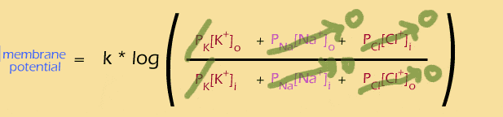](http://mathbench.umd.edu/modules/cell-processes_nernst-potential/page08.htm)

(roll over the equation with your mouse to see the simplified form). **So, if the membrane is only permeable to K+, then the membrane potential would be determined by the concentrations of that ion alone**.

Likewise, what if channels for both K+ and Na+ were open? We know that there's a lot of K+ inside the cell, and a lot of Na+ outside the cell, so:

[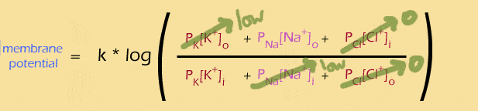](http://mathbench.umd.edu/modules/cell-processes_nernst-potential/page08.htm)

The simplified equation (mouse rollover) is ONLY APPROXIMATE, because the "low" K+ outside and Na+ inside really do matter. But **as an approximation, we could say that if the membrane is only permeable to K+ and Na+, then the ratio of these two terms determines the membrane potential.** This will become important later, when we talk about action potentials.

## The Nernst Equation

 Remember what happened when we specified that the membrane should only be permeable to ONE ion (in this case K+):

[](http://mathbench.umd.edu/modules/cell-processes_nernst-potential/page09.htm)

Here is an even simpler way of stating the same thing, called the "Nernst Equation", and as an added bonus I'll even let you in on the value of the mysterious "k": At normal body temperature , 37oC, “k” is equal to 62 if you measure potential in millivolts AND if you use logarithms in base 10.

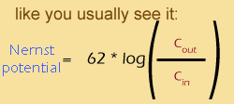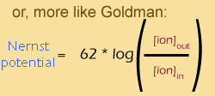

This equation was actually discovered half a century before the Goldman equation, by a Nobel prize winner named Walther Nernst -- hence, the Nernst equation. In the standard version of the equation "C" stands for "concentration". I included the second version just to make the relationship between the Nernst and the Goldman equations more apparent. As you can see the Nernst equation expresses the membrane potential for one particular ion when it is at chemical equilibrium, whereas the Goldman equation takes into account all ions.

By the way, **the value of k = 62 mV comes from the calculation of** 2.303 x RT/ZF, where 2.303 is the conversion from log base e to log base 10, **R is the constant from the gas equation, T is temperature in Kelvin (the absolute temperature), F is the Faraday constant and Z is the valence of the ion. Hence the value of 62 is valid only at body temperature (37oC).** A deep sea fish would have a different value, because of the lower effect of temperature on the potential energy of the ions!

## Taking Nernst for a test drive

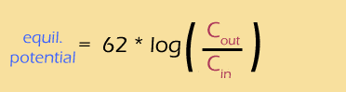

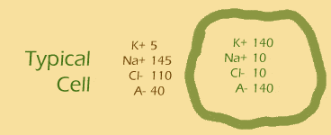

The Nernst equation on the right is related to the Goldman equation but it allows you to calculate the membrane potential for individual ions. Let’s give it a try for the potassium ion and the sodium ion. The figure on the right gives you the information you need for the Nernst equation.

|  |
| --- |
| What is the Nernst potential associated with the potassium ion?  * This problem is basically plug-and-chug * Put the values of [K+]out and [K+]in into the equation * Like this: V = 62 log(5/140) mV * Get your calculator out ! please please please !  Answer: -90 mV |

Bet you thought that was going to be harder... Let's try another one

|  |
| --- |
| What is the Nernst potential associated with the sodium ion?  * [Na+]out is 145 and [Na+]in is 10 * Your calculator is your friend!  Answer: +72 mV |

## More about Nernst



On the previous page, we found Nernst potentials for the two main cations in your cells, and they were quite different:

|  |  |  |
| --- | --- | --- |
| **ion** | potential |  |
| **K+  Nernst potential** | -90mV | K+ |
| **Na+  Nernst potential** | +72mV | K+ |
| **real cell membrane resting potential** | -60 to -80 mV | K+ |

As you can see from the last line of the table, the Nernst potentials we found for the two ions don't even match the resting potential of a real cell membrane! So what gives?

Actually, what's going on is that the Nernst potential is a kind of idealisation -- even a fantasy, if you will -- that is only valid under the two conditions:

1. The membrane is **permeable to the ion under consideration**; and
2. The membrane is **NOT permeable to any other ion**

We know that membranes are not as simple as this, but in fact **the resting potential of most cell membranes is somewhere close to the Nernst potential for K+** ... that suggests that the resting potential is MOSTLY being influenced by K+. And this matches what we know about channels -- **in cells at rest, the K+ channels are generally open and others are generally closed**.

### Simplifying assumptions

In mathematics, the conditions above are known as **"simplifying assumptions"**. There's a reason for making these assumptions -- they make the equations a lot easier to deal with.

## The Nernst equation has more simplifying assumptions than the longer Goldman equation. You may have noticed ****we never actually used the Goldman equation to calculate anything**** -- in part that is because you need a lot more information in order to use the Goldman equation, including concentrations of all the ions and their permeabilities in metres per second!

## The Nernst equation only requires 2 pieces of information – the concentration inside and outside the cell. BUT, it comes up with a rather idealistic answer that doesn’t (exactly) fit reality.

## How about those logs?



I just can't leave this topic without talking at least a little about logs. Sure, when you're just plugging numbers into an equation, you can (should) ask your calculator to do the logs for you. But if you want to understand how the Nernst potential and the concentration gradients are actually related, you really should understand how that log works.

### Multiplying and Adding

Last time we met logs, we were back in the scaling module. A dumb but fairly effective way to remember what logs are is to think of the log as being the length of a log that would be necessary to hold the number, like this

|  |  |
| --- | --- |
| **log** | **log** |
| log size 5 (to hold 5 zeros) | log size 9 (to hold 9 zeros) |

 The important point here is that you only need a slightly bigger log to hold a much bigger number. Put another way, **every time you MULTIPLY the number by 10, you only ADD 1 to the log**.

So what does this mean for the Nernst potential?

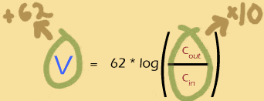

In order to increase the Nernst potential by 62mV, you must multiply the outer concentration of the ion by 10 (or, equivalently, divide the inner concentration by 10).

**Take home message**: Concentration gradient and Nernst potential are NOT proportional to each other! If you double the outer concentration, you do NOT double the Nernst potential.

|  |
| --- |
| Under ordinary conditions, ion X+ has a Nernst potential of -50mV. What will happen to the Nernst potential if the concentration of X+ outside the cell increases by 100 times?  * Multiplying by 100 is the same as multiplying by 10 and then multiplying by 10 again. * Each time you multiply by 10, you add 62mV to the equilibrium potential. * -50 + 62 + 62 = ?  Answer: 74mV |

and (don't skip this one)...

|  |
| --- |
| Under ordinary conditions, ion Y+ has a Nernst potential of -50mV. What will happen to the Nernst potential if the concentration of Y+ outside the cell increases by 5 times?  * Be careful! The log of 5 is NOT half of the log of 10. * log(5) = 0.7 * So MULTIPLYING the gradient by five ADDS 0.7*62 to the potential  Answer: -6.6mV |

What goes up must come down

If multiplying the concentration gradient by ten adds 62mV to the Nernst potential, then it’s a good bet that dividing the gradient by 10 will subtract 62mV from the Nernst potential. Makes sense:

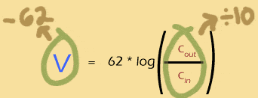

### Logs of numbers less than 1

The log of 1 is 0 -- because there are no zeros or other digits after the 1. But what about the logs of measurements smaller than 1? They get a minus sign (to show that the measurement has only decimal places) but the absolute value of the log tells you how many decimal places -- so log(0.001) is -3, but log(0.000000001) is -9.

|  |  |
| --- | --- |
| **log** | **log** |
| log size -3 (to hold 3  decimal places) | log size -9 (to hold 9  decimal places) |

 So when will we be taking the log of a number smaller than 1?

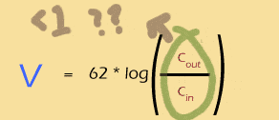

Whenever **Cin is bigger** than Cout, the log will be **negative**.

Whenever **Cout is bigger** than Cin, the log will be **positive**.

If the two are **exactly equal**, the log will be **0** and so will the Nernst potential.

The **bigger the imbalance**, the **bigger the Nernst potential** (either + or -).

So you can see that the log of a ratio is just about perfect for thinking about the ins and outs of a system like this.

|  |
| --- |
| The ion Z+ has a concentration of 125mM outside of the cell and 25mM inside. Will the Nernst potential be positive or negative (no calculator please)!  * Is the concentration gradient ratio more or less than 1? * 125/25 is >1 so the log must be positive  Answer: positive |

## Pumps and Channels

Starting on the next screen, we'll focus on neurons and the use of membrane potential for creating electrical signals. But before we leave the rest of the body behind, I want to once more take a broad view of pumps and channels.

The sodium-potassium pump, which is actually a tiny enzymatic machine, is an amazing evolutionary invention -- the best thing since sliced bread. In fact **about a third of ALL the ATP used by your cells is used to power these pumps**! The sodium-potassium pumps are important for maintaining the membrane potential but they don’t actually contribute directly to the resting potential. How can that be?

We know from the Goldman equation that what matters is the permeability of each ion. And in fact BOTH pumps and channels create permeability, inasmuch as both of them allow ions through the membranes.

But remember that a cell's channels can let up to a million ions through every second. In fact, overall channels move ions 100 times faster than pumps. So, **the "P" related to a pump is much lower than the "P" related to a channel** -- thus, pumps don't really enter into the Goldman or Nernst equations.

(However, the permeability related to pumps DOES matter in bacterial cells, and also in eukaryotic cell organelles, because these cells/organelles don't have channels. So, even though pumps are slow, they are the only game in town -- hence they contribute directly to the membrane potential.)

So if pumps don't contribute to membrane potential (in mammalian cells), then what do they do? Why does the cell spend so much energy on them? Without a pump, the cell wouldn't be able to keep sodium out and potassium in. **Essentially the pumps set up the concentration gradient which then creates the resting potential.** And, as potassium moves out through the membrane channels to the tune of 1 million a second, pumps pump it back in again -- maintaining that all-important concentration gradient.

In fact, as all this is going on, **concentrations inside and outside the cell change barely at all -- that's what's meant by equilibrium**.

Finally, what would happen if you did shut down the sodium-potassium pump? -- which you can in fact do by administering a plant toxin called "ouabain" (see flower to right). In the first few seconds, ouabain has little effect -- as long as the concentration gradient holds up, the membrane's resting potential stays pretty much constant. But, as potassium leaves through the channels, it is not replaced by pumps. So, the concentration gradient slowly decays, wreaking all sorts of havoc...

## At equilibrium, or far from it?

Often when we think of membrane potential, it is in the context of your nervous system. So starting now, we're going to leave cells in your femur, fingertip, and islet of langerhans behind, and focus on neurons.

OK, take a deep breath...

Most materials that you encounter in daily life are either conductors (like copper wire) or insulators (like plastic wrapped around the wire). Cell membranes are different, in that they can rapidly change, depending on their membrane potential -- and nowhere more so than in your nervous system.

The reason these changes can happen rapidly is that, unlike K+, not all of the ions are kept in equilibrium. Exhibit A, the sodium ion:

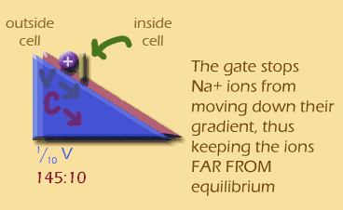

When the cell is resting, sodium ions are kept out-of-equilibrium and out of the cell by "gated" channels in the membrane. These gated sodium channels block sodium from entering the cell. Otherwise, sodium ions would flood in, since they would be moving down their concentration gradient AND, when the cell is at its resting membrane potential, down a voltage gradient. Both gradients want to push Na+ INTO your neurons, and both are blocked by the gated channel. So, sodium is FAR FROM EQUILIBRIUM in the resting cell.

## Opening the gate



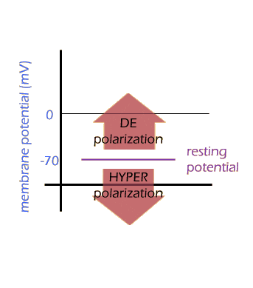

And when you open the gate? Sodium ions rush into the cell, essentially heading down two gradients at once.

That creates a drastic and rapid change in the membrane's potential, called "depolarisation" -- because the charges are becoming less polarised, or separated.

(It's a little confusing to talk about the change in membrane potential. In fact any movement towards a "more positive" membrane potential is called "depolarisation", even if the resulting potential is still negative. And any movement toward a more negative potential is called "hyperpolarisation". This only makes sense because the resting potential is already negative.)

## The Action Potential and the Goldman Equation

 So let's look at the action potential in a little more detail. The first thing that happens is that the gated sodium channels open rapidly, while additional potassium channels also open, but much more slowly. The sodium channels quickly reach a peak and begin to close, while the additional potassium channels lag behind but eventually close as well. Here is one way to visualise that sequence of events:

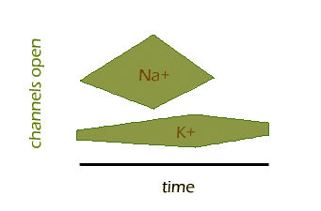

You can see how Na+ channels open and close quickly, while K+ channels take longer. Also, some K+ channels are open before and after the action potential, as we already know.

Can we use the Goldman equation to help predict the membrane potential during an action potential? I'm going to leave out the Cl- terms in the Goldman equation, so we can focus on sodium and potassium.

At the beginning of the action potential, only K+ channels are open, so the membrane potential is negative and fairly similar to the Nernst potential of K+:

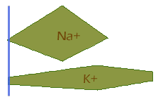**[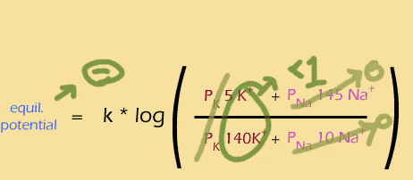](http://mathbench.umd.edu/modules-au/cell-processes_nernst-potential/page16.htm)**

Then the sodium channels open rapidly, boosting the permeability of sodium, causing depolarisation and a positive membrane potential:

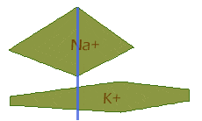 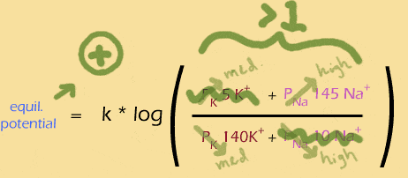

 Notice that the actual number of ions inside and outside the cell have hardly changed AT ALL. All this de-, re-, and hyper-polarisation will happen solely because the permeabilities are changing (i.e., channels are opening and closing). Relative to the number of ions already inside the cell it only takes a very, very small number of ions to enter or leave and change the membrane potential (look back at page 6 where we showed that a million ions a second is really a very small number).

Next the sodium channels have nearly closed just as the potassium channels reach their peak, looking like this:

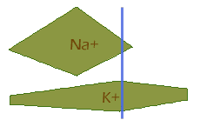**[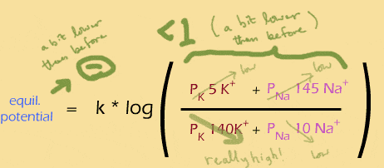](http://mathbench.umd.edu/modules-au/cell-processes_nernst-potential/page16.htm)**

And finally, the extra potassium channels close, leaving the same situation as in the beginning:

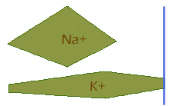 **[](http://mathbench.umd.edu/modules-au/cell-processes_nernst-potential/page16.htm)**

## Action Potential and the Nernst Equation

 An even (!) easier way to think about the action potential is to use the Nernst equation. Remember each ION has its own Nernst potential. Since the concentration gradients of each don't actually change, all that affects the Nernst equation is their permeabilities. **If the membrane is more permeable to sodium, then the membrane potential will be pushed towards the Nernst potential for sodium. Likewise with potassium.**

On the graph below, you see the Nernst potential for each ion, and the permeability of the two ions. Try to trace where you expect the membrane potential to be over time, before you mouse over the image:

[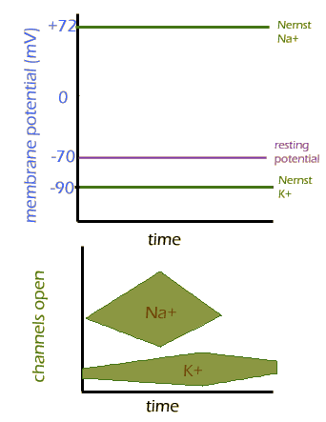](http://mathbench.umd.edu/modules/cell-processes_nernst-potential/page18.htm)

**Summary**

Ions can only pass across the cell membrane by means of channels (NET movement DOWN a gradient) or energy-driven pumps (NET movement AGAINST a gradient).

The flow of ions across a membrane is determined by the concentration gradient and the voltage gradient. The cell membrane is only permeable to some ions – channels are usually open only for potassium ions, so K+ will leak out of the cell leaving a slight negative charge inside. This creates the voltage gradient, which makes K+ ions come back into the cell until equilibrium is reached, i.e. the voltage difference balances diffusion.

The equilibrium membrane potential is determined by the concentrations of all the relevant ions inside and outside the cells, and their permeabilities. The Goldman equation takes account of all ions while the Nernst equation allows you to calculate the membrane potential for individual ions assuming that the membrane is permeable only to that ion.

The membrane potential is closest to the equilibrium potential for K+ which can be determined by the Nernst equation. In its simplified form the Nernst equation is:



Unlike K+, sodium ions are kept out of equilibrium by gated sodium channels. When these channels are opened Na+ rushes into the cell down both concentration and electrical gradients. This results in depolarisation. Voltage-gated potassium channels then open resulting in hyperpolarisation and re-establishment of equilibrium once the action potential has passed.

## Learning Outcomes

**Having completed this module, you should now be able to:**

* Predict how ions will move across a membrane according to their permeability and the electrochemical gradient (concentration gradient plus voltage gradient).
* Calculate the equilibrium membrane potential for each ion using the Nernst equation.
* Use the Goldman equation to predict the membrane potential during an action potential.